
COMSATS University, Islamabad Pakistan

PodVerse

By

Rabeea Chughtai CIIT/SP22-BCS-079/ISB
Sadia Imran CIIT/SP22-BCS-087/ISB

Supervisor
Saadia Maqbool

Bachelor of Science in Computer Science (2022-2026)

COMSATS University, Islamabad Pakistan

PodVerse

A project presented to
COMSATS University, Islamabad

In partial fulfillment
of the requirement for the degree of

Bachelor of Science in Computer Science (2022-2026)

By

Rabeea Chughtai CIIT/SP22-BCS-079/ISB
Sadia Imran CIIT/SP22-BCS-087/ISB

DECLARATION

We hereby declare that this software, neither whole nor as a part, has been copied out from any source. It is further declared that we have developed this software and accompanied report entirely on the basis of our personal efforts. If any part of this project is proved to be copied out from any source or found to be a reproduction of some other, we will stand by the consequences. No Portion of the work presented has been submitted of any application for any other degree or qualification of this or any other university or institute of learning.

Rabeea Chughtai Sadia Imran
--------------------------- ---------------------------

CERTIFICATE OF APPROVAL
It is to certify that the final year project of BS (CS) Dukan was developed by
RABEEA CHUGHTAI (CIIT/SP22-BCS-079) and SADIA IMRAN (CIIT/SP22-BCS-087) under the supervision of SAADIA MAQBOOL and that in her opinion; it is fully adequate, in scope and quality for the degree of Bachelors of Science in Computer Sciences

---------------------------------------
Supervisor

---------------------------------------
External Examiner

---------------------------------------
Head of Department
(Department of Computer Science)

Executive Summary
In today’s digital era, small business owners, entrepreneurs, and content creators increasingly rely on podcasts to share their stories, build brand identity, and connect with audiences. However, the process of producing a podcast remains challenging due to high production costs, the need for technical expertise, difficulty in securing credible guests or hosts, and the time-consuming nature of editing and publishing. These challenges create barriers to entry and limit the consistency and quality of podcast content produced by individuals and small teams.
To overcome these challenges, PodVerse is developed—an AI-powered podcast creation platform designed to simplify and modernize the entire podcast production process. PodVerse serves as a centralized and intelligent system that automates core tasks such as recording, editing, and publishing, while also enabling real-time AI-driven interactions between hosts and guests. By integrating technologies like voice cloning, AI-based conversation agents, and real-time language translation, the system eliminates dependency on external hosts or guests and provides creators with tools to produce engaging, professional-quality podcasts effortlessly.
PodVerse is a web-based platform that offers a user-friendly interface, allowing users with minimal technical skills to plan, record, and publish their podcasts seamlessly. Through automation and personalization modules, users can customize voices, set up AI interviewers or guests, and generate audio-visual podcast episodes suitable for multiple platforms.
This intelligent solution ensures that creators can focus more on content quality and storytelling rather than technical complexities. By making podcast creation more accessible, cost-effective, and interactive, PodVerse empowers users to expand their creative reach, strengthen audience engagement, and grow their brands with confidence.

Abstract
PodVerse is a proposed solution that would make it easy for small business owners, entrepreneurs, and content creators to record high-quality podcasts with no technical skills. Podcasting is highly expensive, requires a lot of technical knowledge, and includes other challenges such as finding credible guests and complex production tools. PodVerse offers AI hosts, guests, voice simulations, and customizable multimedia content creation using pre-designed templates. This decreases the production costs and time together. This is an all-in-one, user-friendly solution that allows solo creators to truly be able to take control over the entire process of podcasting from start to end. The project's primary objectives include reducing production time by 50%, user friendly features for recording as well as publishing. It will eliminate entry barriers for even more users so that they might share their content, build their brands, and contribute to more accessible and efficient podcasts.

Acknowledgement
All praise is to Almighty Allah who bestowed upon us a minute portion of His boundless knowledge by virtue of which we were able to accomplish this challenging task.

We are greatly indebted to our project supervisor “Saadia Maqbool” .Without their personal supervision, advice and valuable guidance, completion of this project would have been doubtful. We are grateful to them for their encouragement and continual help during this work.

And we are also thankful to our parents and family who have been a constant source of encouragement for us and brought us with the values of honesty & hard work.

Rabeea Chughtai Sadia Imran
--------------------------- ---------------------------

Revision History

Name | Date | Reason for Changes | Version

Application Evaluation History

Comments (by committee)  *include the ones given at scope time both in doc and presentation | Action Taken
Scope should be increases, add major  modules  e.g. a usecase where these podcasts can be  used. At the moment the scope is not enough  for 2 students with pretrained models/api  usage. | • Added Social Media Integration for  podcast sharing and engagement.  • Introduced Podcast Summary Feature for  better accessibility and usability.  • Integrated Admin Panel & Analytics for  user/content management and insights.  • Expanded Audience Engagement with  messaging, notifications, and user  interactions.  • Enhanced AI Video Podcast Creation with  avatars, and visual elements
- Tools' usage and purpose are not clear.  - Students' effort is unclear and unjustified with time required.  - Prompt engineering and voice to text generation are unclear to students.  - Lack of existing study | - Implementation demo given for speaker creation.  - Tool usage explained with updated documentation.  - Mockups revised to match implementation.
Student are progressing fine. Podcast Video Creation & Publishing module, the core USP of the project, is yet to be done. It is the most complex and core module. Please make sure that the generated podcast video is of fine quality. Figures and tables must be numbered chapter wise. Each of the tables and figures should be referred in the text. Add brief description before each of the figures. Add references for the related systems. Add algorithms only for the core processing task e.g. no need to document flows for login, password reset etc in the algorithms section. | • Prioritized and implemented the Podcast Video Creation & Publishing module.  • Added quality checks for resolution, audio-video sync, and clarity.  • Updated numbering and included references to all figures and tables.  • Added captions/descriptions to all figures.  • Collected and cited relevant references in the report.  • Documented algorithms only for Core tasks.

Supervised by
Ms. Saadia Maqbool

Signature
Table of Contents
Abstract 6
1. Introduction 6
1.1 Vision Statement 6
1.2 Related System Analysis/Literature Review 6
1.3 Project Deliverables 7
1.4 System Limitations/Constraints 7
1.5 Tools and Technologies 8
1.6 Relevance to Course Modules 8
2. Problem Definition 9
2.1 Problem Statement 9
2.2 Problem Solution 9
2.3 Objectives 9
2.4 Scope 10
2.5 Modules 10
2.5.1 Module 1: User Authentication & Profile Management 10
2.5.2 Module 2: Voice Cloning 10
2.5.3 Module 3: Knowledge Base Setup 11
2.5.4 Module 4: RAG Retrieval 11
2.5.5 Module 5: Agent Customization 11
2.5.6 Module 6: Podcast Audio Creation 11
2.5.7 Module 7: AI Host 11
2.5.8 Module 8: AI Guest 12
2.5.9 Module 9: Podcast Video Creation & Publishing 12
2.5.10 Module 10: FAQs Chatbot 12
2.5.11 Module 11: Audience Engagement 12
2.5.12 Module 12: Admin Panel & Analytics 12
2.5.13 Module 13: Subscription & Payment 13
2.6 Project Contribution 14
3. Requirement Analysis 15
3.1 User classes and characteristics 15
3.2 Requirement Identifying Technique 15
3.2.1 Use Case Diagram 15
3.2.2 Detail Use Cases 19
3.2.3 Event Response Table 59
3.3 Functional Requirements 65
3.3.1 UC-1 Register Account 65
3.3.2 UC-1.2 User Login 68
3.3.3 UC-1.3 Google Authentication 70
3.3.4 UC-1.4 Password Recovery 73
3.3.5 UC-1.5 Logout 76
3.3.6 UC-1.6: Access Sample Podcasts 78
3.3.7 UC-1.7: Start a Podcast Session 79
3.3.8 UC-1.8: View Dashboard 80
3.3.9 UC-1.9: Create and Personalize User Profile 81
3.3.10 UC-1.10: Edit Profile 81
3.3.11 UC-1.11: Follow Creators and View Updates 82
3.3.12 UC-1.12: View Activity Feed of Followed Creators 83
3.3.13 UC-2.1 Voice Cloning Setup 84
3.3.14 UC-3.1 Knowledge Base Setup 86
3.3.15 UC-4.1 AI Agent Customization 88
3.3.16 UC-5.1 Record Podcast Session 89
3.3.17 UC-5.2 Edit, Review, and Export Podcast 92
3.3.18 UC-6.1 AI Host & AI Guest Interaction 98
3.3.19 UC-7.1 Create and Export Video Podcast 100
3.3.20 UC-7.4 Request Podcast Summary 105
3.3.21 UC-7.5 Search for Specific Information in a Podcast Summary 106
3.3.22 UC-7.6 Rate Podcast Session 107
3.3.23 UC-8.1 Ask a Question from FAQs Chatbot 108
3.3.24 UC-8.2 View Suggested FAQs 110
3.3.25 UC-9.1 Receive Notifications for Audience Engagement 111
3.3.26 UC-10.3 Engage with Podcasts (Like, Comment, Share) 112
3.3.27 UC-10.1 Manage User Accounts 113
3.3.28 UC-10.2 Review Reported Content 114
3.3.29 UC-10.3 View Platform Analytics 115
3.3.30 UC-10.4 Manage Subscriptions & Payments 116
3.3.31 UC-10.5 Generate User Engagement Reports 117
3.4 Non-Functional Requirements 118
3.4.1 Usability 118
3.4.2 Performance 119
3.4.3 Security 119
3.4.4 Interoperability 119
3.4.5 Integrity 119
3.5 External Interface Requirements 120
3.5.1 User Interfaces Requirements 120
3.5.2 Software interfaces 120
3.5.3 Hardware interfaces 120
3.5.4 Communications interfaces 120
4. Design and Architecture 121
4.1 Architectural Design 121
4.1.1 MVC Architecture 121
4.2 Design Models 123
4.2.1 Activity Diagrams 123
4.2.2 Class Diagram 135
4.2.3 Sequence Diagrams 151
4.2.4 State Transition Diagrams 159
4.3 Data Design 161
4.3.1 Data Dictionary 161
5. Implementation 168
5.1 Algorithm 168
5.2 External APIs/SDKs 170
5.3 User Interface 170
5.3.1 SignIn 170
5.3.2 Library 171
5.3.3 Home Page 171
5.3.4 Profile 172
5.3.5 Speaker Customization 172
5.3.6 Voice Customization 173
5.3.7 Recording Studio 173
5.3.8 Audio Editing Panel 174
5.3.9 Video Generation 174
5.3.10 Video Editing Panel 175
5.3.11 Admin Dashboard 175
6. Testing and Evaluation 176
6.1 Unit Testing 176
6.2 Functional Testing 180
6.3 Business Rules Testing 183
6.4 Integration Testing 184
7. Conclusion and Future Work 187
7.1 Conclusion 187
7.2 Future Work 187
8. References 188
9. Plagiarism Report 189

Introduction
PodVerse is an AI-powered podcast creation platform developed to simplify and modernize the podcast production journey for small business owners, entrepreneurs, and content creators. By eliminating technical barriers such as high production costs, complex editing processes, and challenges in finding credible guests, PodVerse enables creators to produce engaging, high-quality podcasts effortlessly. The system integrates advanced technologies like voice cloning, real-time AI interactions, and customizable avatars, providing users with a centralized solution for planning, recording, editing, and publishing their podcast content. With a user-friendly interface and modules tailored for automation and personalization, PodVerse ensures seamless experience, empowering creators to build consistent content and strengthen audience engagement.

Vision Statement
For small business owners, entrepreneurs, and content creators, the PodVerse platform is a podcast creation tool that automates key processes like voice cloning, editing, and publishing. Unlike traditional podcast production methods that require technical skills and high costs, our product enables users to create audio and video podcasts easily. By using innovative AI-driven solutions, PodVerse eliminates barriers to entry for podcast creators, enabling them to produce content efficiently. Designed for ease of use, the platform caters to users with minimal technical knowledge while offering advanced options for creators, ensuring a seamless and effective podcasting experience.

Related System Analysis/Literature Review

Table 1.1: Related System Analysis

Application Name | Weakness | Proposed Project  Solution
Podcastle | Limited to editing, no guest coordination. | PodVerse simulates AI guests for seamless content creation.
Descript | Lacks AI hosts and customizable 3D avatars. | PodVerse includes AI hosts/guests and customizable avatars for enhanced personalization.
Anchor | Basic recording lacks advanced editing and AI tools. | PodVerse provides advanced editing, voice simulation, and AI-driven content for streamlined production.

Project Deliverables

The PodVerse project will deliver the following key components:
- Web-Based Platform: A functional system for planning, recording, editing, and publishing podcasts.
- AI Voice System: Enables creation of custom AI hosts or guests using voice cloning.
- Real-Time Interaction: Supports natural, intelligent conversations between users and AI agents.
- Knowledge Base Integration: Ensures topic-specific and accurate AI discussions.
- Editing & Publishing Tools: Provides simple trimming, transcription, and export options (MP3/WAV).
- Documentation & Demo: Delivers technical documentation and a working prototype showcasing system capabilities.

System Limitations/Constraints

LI-1: Requires a stable, high-speed internet connection, limiting use in areas with poor connectivity.
LI-2: Supports basic audio/video podcasting but lacks advanced video production features.
LI-3: Voice simulation may not fully capture emotional nuance, affecting content engagement.
LI-4: Primarily designed for small to medium-sized businesses; larger organizations may need customization.
LI-5: Limited customization options for audio/video content, which may restrict users looking for highly personalized or advanced features in podcast production
LI-6: Relies on AI-generated voices, which may not fully replicate natural human speech patterns, leading to a less authentic listening experience.

Tools and Technologies

Table 1.2: Tools and Technologies for Proposed Project

Tools And  Technologies | Tools | Version | Rationale
Tools And  Technologies | Visual Studio Code | 1.84 | IDE
Tools And  Technologies | MS Word | 365 | Documentation
Tools And  Technologies | MS PowerPoint | 365 | Presentation
Tools And  Technologies | Figma | 116.4.2 | Mockups Creation
Tools And  Technologies | Supabase | 2.39 | Database
Tools And  Technologies | Technology | Version | Rationale
Tools And  Technologies | ReactJS | 18.2.0 | Front-End development
Tools And  Technologies | FastAPI | 4.19.2 | Back-End development
Tools And  Technologies | NodeJS | 21.7.0 | Front-End development
Tools And  Technologies | Python | 3.13.0 | Deep Learning Models

Relevance to Course Modules

The development of PodVerse, an AI-powered podcast creation platform, is closely connected to the key concepts learned throughout the Bachelor of Science in Computer Science (BSCS) program.
Courses such as Programming Fundamentals (CSC103), Object-Oriented Programming (CSC241), and Data Structures and Algorithms have helped in designing the core structure of PodVerse, ensuring efficient logic flow and smooth functionality.
Modules like Artificial Intelligence (CSC462) and Machine Learning (CSC354) directly contributed to building intelligent and interactive features such as the AI Host, AI Guest, and real-time conversation handling.
Additionally, Database Systems (CSC270) supported efficient data organization and management for user accounts, podcast storage, and AI knowledge bases.
Courses such as Software Engineering Concepts (CSC291) and Parallel and Distributed Computing (CSC334) guided the architectural design, ensuring the system’s modularity, scalability, and efficient real-time processing.

Problem Definition

Problem Statement

It is difficult for new journalists not to secure well-known interview guests available for their shows, which restricts the amount of impactful content they can produce and build up in their portfolio. Podcasting companies also face very high production costs as often, a lot of money is spent securing a famous host, and dealing with arranging times and recording is costly. This is impossible for small businesses and entrepreneurs already short on time to consistently produce good podcasts, not knowing sufficient technical skill, thus not growing their brand. Similarly, online content creators on different social platforms, including YouTube, find it hard to scale into podcasting considering the time-consuming nature of podcast production that limits them from boosting their content. Such significant obstacles create barriers to entry and growth for the podcasting industry.

Problem Solution

The disadvantages faced in podcast production can be addressed by providing a solution that automates the core processes involved, such as recording, editing, and publishing. This would mean that there would never be a dependency on external hosts or guests since customizable voices and tones could be integrated into this system, enabling the creators to produce interesting podcasts independently. The ease of use would make this interface accessible for individuals with little technical skills to allow them to create worthy content without being overwhelmed by the technical hurdles. The system, on its own, would help create a natural flow of conversation within the content, thereby making listening interesting for the target audiences. Also, a solo creator would be able to create avatar videos from audio and publish them on desired platforms. This innovative approach would ultimately make it possible for creators to establish and grow their brands with success, giving them all that they need to share their stories to the world and bring it close to its concerned audiences.

Objectives
BO-1: Make podcast creation effortless by allowing users to clone voices and host podcasts with AI, removing the hassle of finding real guests and handling technical complexities.

BO-2: Enable users to create quality podcasts without requiring technical skills or extra resources.

BO-3: Enhance accessibility to podcast production tools, making it easier for creators to produce and share content effectively.

BO-4: Support businesses in building their brand and engaging audiences with high-quality podcasts.

Scope

PodVerse is an all-in-one system that helps business owners, entrepreneurs, content creators, and journalists make podcasts easier and better. PodVerse enables users to concentrate on content creation while utilizing advanced AI functionalities to manage technical duties by automating key aspects of production. The platform has features like voice cloning, editing, and recording podcasts with AI agents that help solo performers overcome common problems like finding reliable guests and coordinating schedules PodVerse provides avatars and pre-designed visual templates, allowing users to produce audio and improved video podcasts. People with varying levels of technical expertise can utilize it because of its intuitive design. User profiles and engagement tools are also included in the platform, enabling users to customize their profiles, follow their favorite creators, and communicate with one another through shares, likes, and comments. An integrated communication platform supports user-to-user messaging and calls, building an active community.
With its user-centered approach, PodVerse ensures high-quality content creation, making podcasting a more feasible and useful medium for brand building and audience interactions.

Modules

Module 1: User Authentication & Profile Management
This module manages authentication, profile customization, and dashboard access for secure login and content engagement.
FE-1: Account creation via email with verification.
FE-2: Secure login via email/password.
FE-3: Password recovery via email verification.
FE-4: Secure Logout.
FE-5: Creator’s dashboard for sample podcasts and AI Agent management.
FE-6: View and edit profiles.
FE-7: Activity feeds with updates from followed creators.

Module 2: Voice Cloning
This module allows users to create and manage voice samples for cloning. FE-1: Enabling the recording or upload of voice samples for cloning. FE-2: Allowing users to preview voice samples to check on the quality.
FE-3: Allow users to re-record or re-upload if the sample is not as desired.
FE-4: Allow the availability of a library with voices.

Module 3: Knowledge Base Setup
This module facilitates the setup and management of a knowledge base for retrieval.
FE-1: Allow users to upload data in PDFs, URLs, CSV, or JSON.
FE-2: Data is cleaned, processed, and split into meaningful chunks for easy handling.
FE-3: Tag chunks with metadata and link to original sources.
FE-4: Store chunks in a database and generate vector embeddings for better retrieval.

Module 4: RAG Retrieval
This module enhances the retrieval of accurate and relevant information from the knowledge base.
FE-1: Convert queries into vectors to determine purpose.
FE-2: Match vectors with knowledge base data for accurate responses.
FE-3: Re-rank data by relevance for better answers.
FE-4: Provides fact-based correct answers for podcasts.
FE-5: Optimized for large datasets without loss of performance.
FE-6: Allow feedback to enhance agent response quality.

Module 5: Agent Customization
This module allows users to personalize their AI agents.
FE-1: Users can assign a custom name to their AI agent.
FE-2: Users can choose from various voice options to suit their podcast.
FE-3: Users can select or upload an avatar to visually represent their AI agent.

Module 6: Podcast Audio Creation
This module provides tools for creating and publishing podcasts.
FE-1: Let users start dialogues with a customized AI agent.
FE-2: Conversations recorded for user and AI agent.
FE-3: Users allowed minimal editing to trim and splice to rearrange things. FE-4: Allow users the ability to preview edited podcasts for flow and polish. FE-5: Export podcasts in MP3/WAV.
FE-6: Save recordings for future use.

Module 7: AI Host
This module provides an AI host to manage the flow of podcasts.
FE-1: AI Host presents the flow of podcasts, introduces the episodes and closes with a summary.
FE-2: Tracks podcast time and gives reminders for the schedule.
FE-3: Facilitates smooth transitions between guests or topics.
FE-4: Provides summary prompts to summarize key points for clarity and engagement.

Module 8: AI Guest
This module provides an AI guest to enhance podcast discussions.
FE-1: AI Guest responds to real-time queries using dynamic responses. FE-2: AI Guest shares appropriate stories to add depth to the discussion. FE-3: AI Guest gives back comments/reactions to facilitate engagement.

Module 9: Podcast Video Creation & Publishing
This module enables the creation of video content for podcasts, and AI-generated text summaries.
FE-1: Users select avatars for each of the speakers.
FE-2: The system syncs based on the audio of the podcast.
FE-3: Users can choose from the pre-defined templates and visuals for the video.
FE-4: Pre-designed split-screen video template with two avatars.
FE-5: Exports the final video in MP4 format or publish the final video.
FE-6: Allow creators to rate podcast sessions.
FE-7: Provide written feedback on conversation skills, voice clarity, and AI accuracy.

Module 10: FAQs Chatbot
This module provides a chatbot to answer frequently asked questions.
FE-1: Users can ask about podcasting, AI customization, or troubleshooting.
FE-2: The chatbot retrieves relevant answers from the FAQs and support materials.
FE-3: Provides concise, direct responses for quick problem resolution.

Module 11: Audience Engagement
This module enables audience interaction, and podcast feedback to enhance creator engagement.
FE-1: Notifications for creators about audience interactions.
FE-2: Highlighting top creators and trending content.
FE-3: Generate and display a text-based summary of podcast episodes.

Module 12: Admin Panel & Analytics
This module provides administrative functionalities, including user management, content moderation, analytics, and system configuration.
FE-1: Allow admin to view, search, deactivate, reactivate, or delete user accounts
FE-2: Enable admin to review reported podcasts and comments.
FE-3: Display live statistics on active users, total podcasts created, trending content, user engagement heatmaps, and demographics.
FE-4: Provide insights into user engagement, podcast performance, and trending topics.

Module 13: Subscription & Payment
This module manages subscription and payment processes.
FE-1: Let users access some free, limited content.
FE-2: After the limit, users are prompted to subscribe for continued access.
FE-3: Secure payment gateway integration supporting credit/debit cards. FE-4: User can control subscriptions, see payment history, change methods. FE-5: Give reminders before expiration with options of auto-renewal.

Project Contribution

PodVerse introduces several innovations that simplify and modernize podcast creation through AI and automation:
- AI-Driven Podcasting: Enables fully automated conversations using AI hosts and guests, eliminating the need for real participants.
- Voice Cloning: Allows users to create customized and realistic voices for hosts or guests.
- Editing Platform: Provides basic yet efficient tools for audio cleanup and trimming to simplify podcast production and improve overall quality.
- Knowledge Base Integration: Lets AI access user-uploaded files to provide factual, brand-specific, and context-aware responses.
- Supabase-Powered Cloud Storage: Ensures secure, scalable, and real-time data management for users and podcast content.
These contributions make PodVerse an innovative, user-friendly, and cost-effective solution that empowers creators to produce professional-quality podcasts without technical expertise.

Requirement Analysis

User classes and characteristics

Table 3.1: User Classes

User class | Description
Admin | The admin oversees platform management, ensuring compliance and smooth operations. They can manage user accounts, moderate flagged content, track subscriptions, and analyze revenue reports. Admins access a dedicated dashboard displaying real-time statistics, engagement trends, and system insights. The admin ensures PodVerse remains a secure and well-regulated environment.
Creator | The Creator is a user who records, edits, and publishes podcasts. Each Creator has their own channel, where they can post episodes, manage content, and customize their AI hosts/guests. They can track performance analytics such as views, shares, engagement, and listener demographics through the Channel Insights Dashboard. Creators can also utilize AI-powered tools like voice cloning and language translation to enhance their podcasts.
Viewer | The Viewer is a user who consumes podcast content but does not have a channel. They can follow Creators, engage through likes, comments, and shares, and receive notifications about new episodes. Viewers can explore trending podcasts, search for topics of interest, and provide feedback on episodes. While they do not create content, they contribute to community engagement and content discovery.

Requirement Identifying Technique
This section describes the techniques that identify PodVerse’s requirements in such a way that it maps a way for PodVerse Final Document better understanding of its functional and non-functional requirements.

Use Case Diagram
Below is the case diagram of the Creator (Figure 3.1) Viewer (Figure 3.2) Admin (Figure 3.3).

Creator
Below is the use case diagram of Actor-Creator
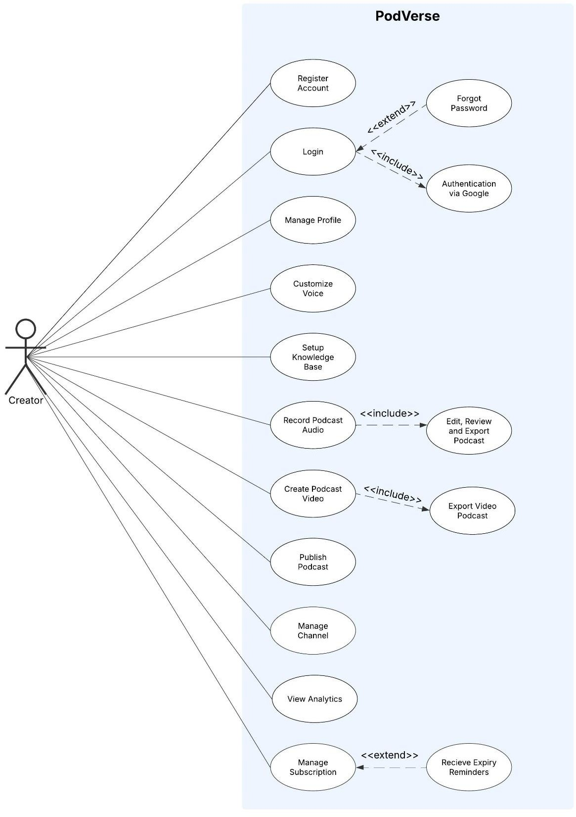

Figure 3.1: Use Case Diagram of Creator

Viewer
Below is the use case diagram of Actor-Viewer
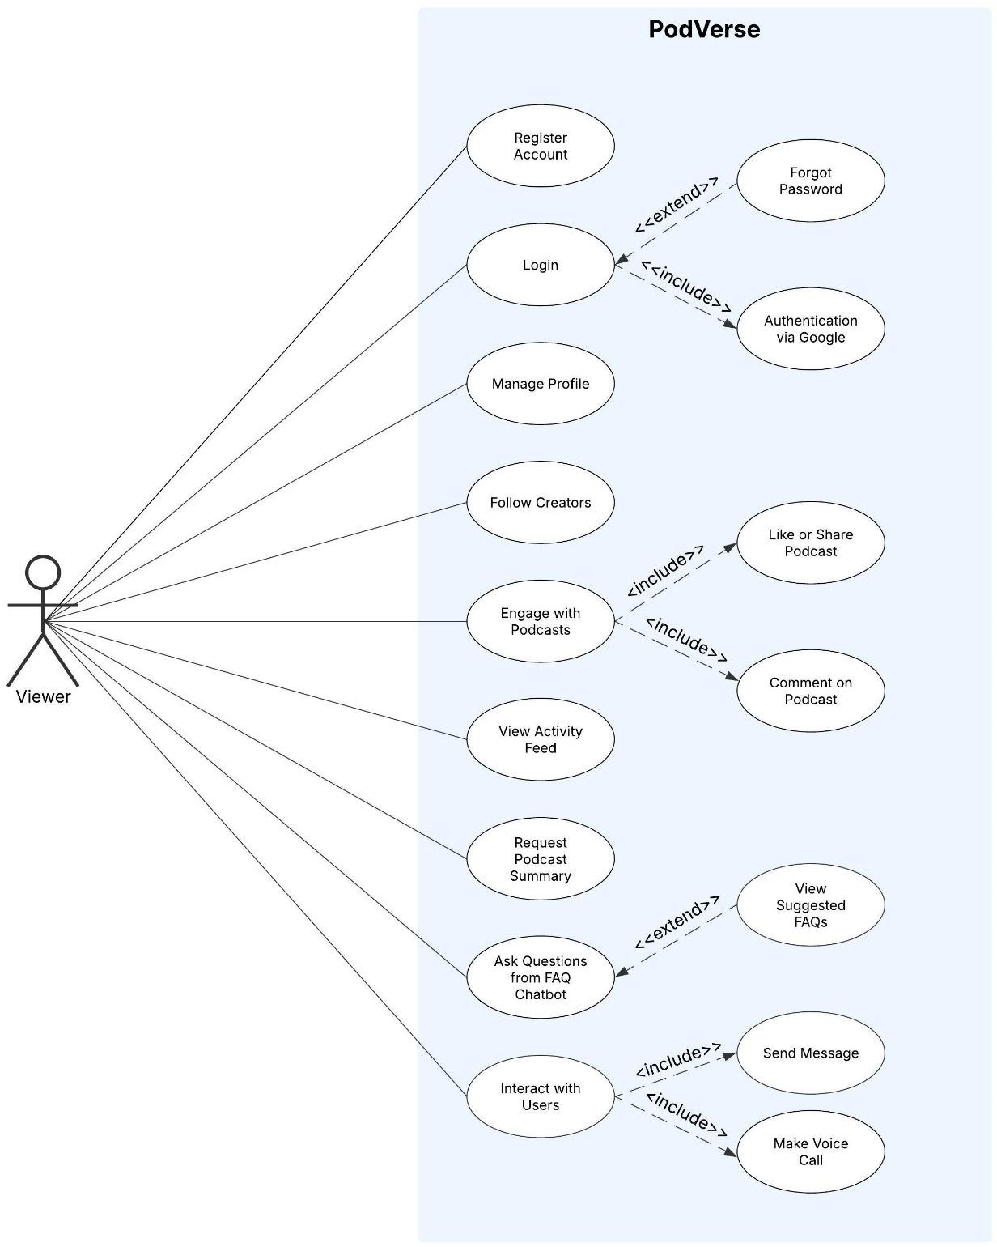

Figure 3.2: Use Case Diagram of Viewer

Admin
Below is the use case diagram of Actor-Admin

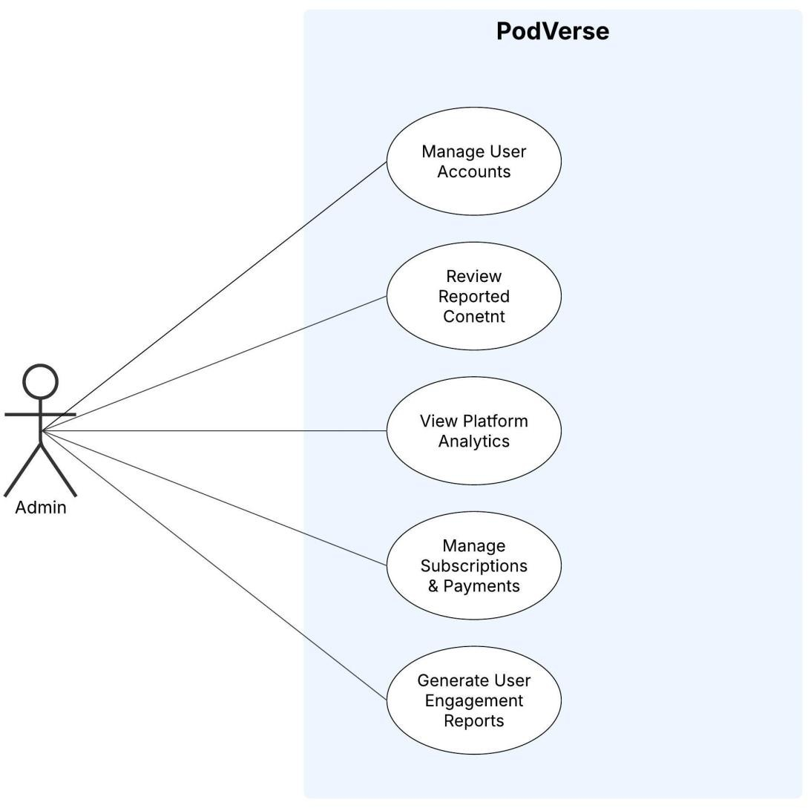

Figure 3.3: Use Case Diagram of Admin

Detail Use Cases

Module 1: User Access & Profile Management

UC-1.1: Register Account
In this case, a user registers via email/password or social login. The system ensures email uniqueness and password strength, requiring email verification for email-based sign-ups, while social logins bypass this step for seamless access.

Table 3.2: UC-1.1 Register Account

Actors: | User
Trigger: | User selects the "Sign Up" option from the login page.
Preconditions: | PRE-1: User has a valid email.  PRE-2: User has an internet connection.
Postconditions: | POST-1: User account is created and stored.  POST-2: A verification email is sent.  POST-3: User can log in after verifying email.
Normal Flow: | 1.0 Register Account  - User selects the "Sign Up" option.  - User enters email & password. (See 1.0. E1, 1.0. E2)  - System checks uniqueness & password strength.  - If valid, system creates the account and sends a verification email. (See 1.0. E3)  - User verifies the email.  - User is redirected to the dashboard.

Alternative Flows: | - Register via Social Login  - User selects Google/Facebook login instead of email/password.  - System retrieves user details & skips email verification.
Exceptions: | EX-1: 1.0. E1: Email already in use  System prompts the user to enter a new one.  2a. If the user cancels, the system terminates registration.  2b. If a user enters a new email, use case resumes at step 2.  EX-2: 1.0. E2: Weak password entered  System prompts users to meet security criteria.  EX-3: 1.0. E3: Verification link expired  System allows resending a new link.
Business Rules: | BR-1: Email must be unique.  BR-2: Password must meet security criteria.  BR-3: Email verification is mandatory before login.
Assumptions: | - User has a working email.  - OAuth login is configured properly.

UC-1.2: User Login
A registered user logs in using email/password or social login (Google/Facebook). The system verifies credentials and grants access to the dashboard. If authentication fails, appropriate error messages are shown, and multiple failed attempts may trigger a temporary lock.

Table 3.3: UC-1.2 User Login

Actors: | User
Trigger: | User selects the "Log In" option from the login page.

Preconditions: | PRE-1: User must have a registered account.  PRE-2: If using email/password, account must be verified.
Postconditions: | POST-1: User session is created.  POST-2: User is redirected to the dashboard.
Normal Flow: | 1.0 User Login  - User enters email & password. (see 1.0.E1, 1.0.E2)  - System validates credentials.  - If valid, system creates a session and logs the user in.
Alternative Flows: | - Social Login  - User logs in via Google/Facebook.  - System verifies identity and logs user in directly.
Exceptions: | EX-1: 1.0. E1: Incorrect password  System prompts for a retry.  EX-2: 1.0. E2: Unverified email  System notifies the user to verify the email.  EX-3: 1.0. E3: Account not found  System suggests creating a new account.
Business Rules: | BR-1: Only verified accounts can log in.  BR-2: Multiple failed login attempts should trigger temporary lockout.
Assumptions: | - Users know their credentials.  - System is connected to authentication services.

UC-1.3: Google Authentication
A user logs into PodVerse using Google authentication for a seamless and secure login. The system verifies credentials via Google and grants access, eliminating the need for a separate password.

Table 3.4: UC-1.3 Google Authentication

Actors: | User, Google Authentication System
Trigger: | User selects the "Sign in with Google" option on the login page.
Preconditions: | PRE-1: User must have a valid Google account.  PRE-2: System must support Google OAuth authentication.
Postconditions: | POST-1: User is authenticated and logged into PodVerse.  POST-2: Google account is linked for future logins.
Normal Flow: | 1.0 Login with Google  - User selects "Sign in with Google".  - System redirects the user to Google’s authentication page.  - User enters Google credentials. (see 1.0.E1)  - Google requests permission for authentication.  - User grants permission.  - System retrieves user details and logs them in.
Alternative Flows: | 1.1 Auto-login for linked accounts  1. If the user has previously linked to their Google account, they are logged in directly.
Exceptions: | EX-1: 1.0.E1: Google authentication fails  System displays an error and prompts the user to retry.  EX-2: 1.0.E2: User denies permission  System cancels login and redirects to the login page.

Business Rules: | BR-1: Only valid Google accounts can be used for authentication.  BR-2: If the user has not registered before, Google login creates a new account with retrieved details.
Assumptions: | - User has an active internet connection.  - Google authentication services are operational.

UC-1.4: Password Recovery
In this case, a user resets their password using the "Forgot Password" option. The system verifies the entered email and sends a password reset link. The user clicks the link, enters a new password, and the system updates their credentials. If the email is unregistered or the reset link has expired, appropriate error messages are displayed.
Table 3.5: UC-1.4 Password Recovery

Actors: | User
Trigger: | User selects the "Forgot Password" option from the login page.
Preconditions: | PRE-1: User must have a registered email.
Postconditions: | POST-1: A password reset link is sent to the user.  POST-2: User sets a new password.
Normal Flow: | 1.0 Password Recovery  - User clicks "Forgot Password".  - User enters a registered email. (See 1.0. E1)  - System sends a password reset link.  - User clicks the link and enters a new password. (See 1.0. E2)  - System updates the password and confirms the change.

Alternative Flows: | 1.1 Request New Reset Link  1. User requests a new reset link if the previous one expired.
Exceptions: | EX-1: 1.0. E1: Email not registered  1. System displays an error message.  2a. If the user cancels, the process terminates.  2b. If a user re-enters an email, resume at step 2.  EX-2: 1.0. E2: Reset link expired  1. System prompts the user to request a new one.
Business Rules: | BR-1: Reset links should expire within 30 minutes.  BR-2: New password must meet security criteria.
Assumptions: | - Users can access their email.  - Reset links work only for registered users.

UC-1.5: Logout

In this case, a User can securely log out from their active session in the application. The User will initiate the logout process, which will end their active session and redirect them to the login page.

Table 3.6: UC-1.5 Logout

Actors: | User
Trigger: | User selects the log out option on dashboard page.
Preconditions: | PRE-1: User must be logged in.  PRE-2: User must be on Dashboard Page.
Postconditions: | POST-1: User is logged out of the application.
Normal Flow: | 1.0 Initiate Logout Process  - User selects the logout option on the dashboard page. (see 1.1, 1.2)  - System displays a confirmation message, “Are you sure you want to logout?”  - User confirms their intention to logout by selecting “OK”. (See 1.0. E1)  - System logs the user out and redirects them to login page.
Alternative Flows: | - Cancel logout process  - User selects the option to cancel during the logout confirmation step. (see 1.0)  - System does not proceed with the logout and use case terminates.  - No active internet connection  - Users try to log out without an active internet connection. (see 1.0)  - System displays a message: "Internet connection is required to log out."  - System does not proceed with the logout and use case terminates.
Exceptions: | EX-1: 1.0. E1 Server or system error during logout  1. System encounters an unexpected error, such as a server issue, during the logout process.  2a. If the user attempts to log out again, the system retries the logout process. 2b. Else if the user decides not to retry and cancels, the use case terminates.
Business Rules: | N/A
Assumptions: | - An active internet connection is available to the user.

UC-1.6: Access Sample Podcasts
A user browses sample podcasts for inspiration before starting their own podcast.

Table 3.7: UC-1.6 Access Sample Podcasts

Actors: | User
Trigger: | User selects "Sample podcasts" from the dashboard panel.
Preconditions: | PRE-1: User must be logged in.  PRE-2: User has an internet connection.
Postconditions: | POST-1: Sample Podcasts are displayed.
Normal Flow: | - Users navigate Sample Podcasts.  - System loads featured sample podcasts.  - User plays, pauses, or skips through podcasts.
Alternative Flows: | AF-1: User searches for specific sample podcasts using a filter.
Exceptions: | EX-1: No Sample podcasts are found.
Business Rules: | BR-1: Only verified users can access sample podcasts.
Assumptions: | - User has an active internet connection.

UC-1.7: Start a Podcast Session
A user wants to start a podcast session with either an AI guest or AI host.

Table 3.8: UC-1.7 Start a Podcast Session

Actors: | Creator
Trigger: | Creator logs in and selects "Start New Session".
Preconditions: | PRE-1: User must be logged in.  PRE-2: User must have access to AI Guest or AI Host.
Postconditions: | POST-1: User can now specify the settings for podcast session firstly agent customization.
Normal Flow: | - Users navigate to Start a New Session.  - Users choose to continue either with AI Host or AI Guest.  - User can now set the Agent customization.
Alternative Flows: | If there is an Incomplete Session.  - Incomplete Session is opened.  - Resume from the previous saved session.
Exceptions: | EX-1: Credits are finished.
Business Rules: | BR-1: Only verified users can access sample podcasts.
Assumptions: | - User has an active internet connection.  - User has credits to create a podcast session.

UC-1.8: View Dashboard
A user wants to go to Dashboard screen or home screen.

Table 3.9: UC-1.8 View Dashboard

Actors: | User
Trigger: | User selects the home option on dashboard screen.
Preconditions: | PRE-1: User must be logged in.
Postconditions: | POST-1: User sees a list of relevant posts based on their profile and the people they have followed.
Normal Flow: | - User selects the “home” option.  - System retrieves and displays a list of podcasts based on:  - User's own podcasts.  - Posts from users they follow.  - Public posts (depending on platform privacy settings).
Alternative Flows: | N/A
Exceptions: | EX-1: No internet connection  - System shows an error message.  - System tries to reload.
Business Rules: | BR-1: Appropriate content moderation policies must be implemented.
Assumptions: | - Users can locate the home option from nav-bar on Dashboard screen.

UC-1.9: Create and Personalize User Profile
In this case, a user creates and customizes their profile, including setting a display name, uploading a profile picture, and adding personal details.
Table 3.10: UC-1.9 Create and Personalize User Profile

Actors: | User
Trigger: | User navigates to the profile section for the first time.
Preconditions: | PRE-1: User must be logged in.  PRE-2: System must allow users to update profile information.
Postconditions: | POST-1: The user profile is created and saved.  POST-2: User can update their profile at any time.
Normal Flow: | 1.0 Create and Personalize User Profile  - User navigates to "My Profile".  - System prompts the user to enter profile details (display name, bio, profile picture).  - User enters the required details. (see EX-1)  - System saves and updates the user profile.  - The profile is displayed on the user’s page.
Alternative Flows: | - Modify Profile Details  - User revisits "My Profile" to update details.  - System allows changes to profile picture, bio, and personal settings
Exceptions: | EX-1: Invalid file format for profile picture  - System rejects the upload and prompts the user to select a supported format.
Business Rules: | BR-1: Users must provide a unique display name.  BR-2: Profile updates should be saved immediately.

Assumptions: | 1. Users will regularly update their profile to reflect their activity.

UC-1.10: Edit Profile
In this case, a user wants to modify their profile details. They can update their username, profile picture, or password. Once the changes are made, the system ensures the updated information reflects in the user's profile.
Table 3.11: UC-1.10 Edit Profile

Actors: | User
Trigger: | User selects edit profile option on dashboard page.
Preconditions: | PRE-1: User must be logged in.
Postconditions: | POST-1: System updates the User information
Normal Flow: | 1.0 Edit User Profile  - User selects edit profile option in dashboard page.  - User updates phone number if required.  - User updates username if required. (See 1.0. E1)  - User updates picture if required.  - User updates password if required. (See 1.0. E2)  - The system updates the user information.
Alternative Flows: | - Password Updates  - User enters the new password.  - Users re-enter the password for confirmation.  - System checks if the two passwords match (see 1.1 E1).  - If they match, the system updates the password and use case resumes at step 6 of the normal flow.
Exceptions: | EX-1: 1.0. E1 Username already registered  1. System notifies the user that the chosen username has already taken. 2a. If the user provides an alternate username, the use case resumes from step 3 of the normal flow.  2b. Else if the user decides to exit the registration process, the use case terminates.  EX-2: 1.1. E2 Password Strength Insufficient  1. System informs user that the password doesn't meet the required criteria.  2a. If the user modifies the password according to guidelines, the use case resumes at step 5 of the normal flow.  2b. Else if the user cancels the password update process, the use case resumes at step 6 of the normal flow.  EX-3: 1.1. E1 Password and Confirm Password Mismatch  1. System notifies User that the entered passwords don't match.  2a. If a user re-enters matching passwords, use case resumes at step 6 of the normal flow.  2b. Else if the user cancels the password update process, the use case resumes at step 6 of the normal flow.
Business Rules: | BR-1: Only one account can be registered for a given username.  BR-2: The password must be a strong password with both alphabet and digits
Assumptions: | - Users know that edit profile will change the previous information.  - An active internet connection is available to the user.

UC-1.11: Follow Creators and View Updates
In this case, a user follows their favorite podcast creators to receive updates on new episodes and activity.

Table 3.12: UC-1.11 Follow Creators and View Updates

Actors: | Viewer
Trigger: | User selects the "Follow" button on a creator’s profile.
Preconditions: | PRE-1: User must be logged in.  PRE-2: The creator’s profile must be publicly available.
Postconditions: | POST-1: The user starts following the creator.  POST-2: Updates from the creator appear in the user’s feed.
Normal Flow: | 1.0 Follow a Creator  - User visits a creator’s profile.  - User clicks "Follow".  - System updates the user’s following list.  - System adds creator’s updates to the user’s feed.
Alternative Flows: | - Unfollow a Creator  - User visits a followed creator’s profile.  - User clicks "Unfollow".  - System removes the creator from the following list.
Exceptions: | EX-1: Creator's account is deleted or deactivated  - System removes the creator from all users' following lists.
Business Rules: | BR-1: Users can follow or unfollow creators at any time.
Assumptions: | - Creators regularly update their content.

UC-1.12: View Activity Feed of Followed Creators
In this case, a user views a feed displaying updates from followed creators.

Table 3.13: UC-1.12 View Activity Feed of Followed Creators

Actors: | Viewer
Trigger: | User navigates to "Activity Feed" on home page.
Preconditions: | PRE-1: User must be logged in.  PRE-2: User must follow at least one creator.
Postconditions: | POST-1: System displays updates from followed creators.
Normal Flow: | 1.0 View Activity Feed  - The user selects "Activity Feed".  - System loads recent updates from followed creators.  - User browses through new content, comments, and interactions.
Alternative Flows: | N/A
Exceptions: | EX-1: No activity available  - System informs the user and suggests following more creators.
Business Rules: | BR-1: Activity feed updates should be in real-time.
Assumptions: | - Creators actively post updates.

Module 2: Voice Cloning

UC-2.1: Voice Cloning Setup
In this case, a user records, uploads, or selects a voice sample for AI voice cloning. The system processes the sample, generates a cloned voice, and allows the user to preview and save it. If unsatisfied, the user can re-record, re-upload, or choose from AI-generated voices for customization.
Table 3.14: UC-2.1 Voice Cloning Setup

Actors: | Creator
Trigger: | User selects the "Voice Cloning" option from the settings or AI customization menu.
Preconditions: | PRE-1: User must be logged in.  PRE-2: System must support voice recording and AI processing.
Postconditions: | POST-1: A voice sample is recorded, uploaded, or selected.  POST-2: The system processes and saves the voice model.
Normal Flow: | 1.0 Voice Cloning Setup  - User selects "Voice Cloning" from settings.  - System prompts the user to record or upload a voice sample.  - User records or uploads a sample. (See 1.0. E1, 1.0. E2)  - System processes the sample for cloning.  - User previews the generated AI voice.  - If satisfied, the user confirms and saves the AI-generated voice.
Alternative Flows: | - Modify Cloned Voice  - If the user is not satisfied, they can re-record or re-upload a sample. (See 1.1. E1)  - User can select a voice from the AI-generated voice library instead of recording their own.
Exceptions: | EX-1: 1.0. E1: Poor-quality recording  1. System prompts the user to retry.  EX-2: 1.0. E2: Unsupported file format for upload  1. System notifies the user and requests a valid format.  EX-3: 1.1. E1: User rejects generated voice.  1. System allows re-recording, re-uploading, or selection from the AI-generated voice library.
Business Rules: | BR-1: Voice cloning should meet quality standards before being saved.  BR-2: Users should be able to re-record or modify their cloned voice.
Assumptions: | - User has a functioning microphone if recording a voice sample.  - The system has AI capabilities to process and generate voices.

Module 3: Knowledge Base Setup

UC-3.1: Knowledge Base Setup
In this case, a user uploads structured or unstructured data into the AI system’s knowledge base. The system processes, cleans, and organizes the data into meaningful chunks for better AI retrieval. Metadata is attached to ensure accurate responses, and the final processed data is stored in a vector database.
Table 3.15: UC-3.1 Knowledge Base Setup

Actors: | Creator, System
Trigger: | User selects the "Upload Knowledge Base" option from the settings or AI customization menu.
Preconditions: | PRE-1: User must be logged in.  PRE-2: User must have valid data sources in supported formats (PDFs, URLs, CSV, JSON).  PRE-3: System must have available storage for data processing.
Postconditions: | POST-1: Uploaded data is processed and stored.  POST-2: Data is split into meaningful chunks with metadata attached.  POST-3: System generates vector embeddings for efficient retrieval.
Normal Flow: | 1.0 Knowledge Base Upload  - User selects "Upload Knowledge Base".  - System prompts the user to choose a data source (PDF, URL, CSV, JSON).  - User uploads the file or enters a URL. (See 1.0. E1)  - System scans data for formatting issues.  - System cleans and preprocesses data.  - Data is split into structured chunks with metadata.  - System generates vector embeddings for AI retrieval.  - Processed data is stored in the vector database.  - System confirms successful upload.
Alternative Flows: | - Metadata Enhancement  - System detects missing metadata. (See 1.1. E1)  - System suggests default metadata values.  - User manually updates metadata if necessary.
Exceptions: | EX-1: 1.0. E1: File format unsupported  - System notifies the user and requests a valid format.  EX-2: 1.0. E2: URL is unreachable.  - System notifies the user and allows them to enter another URL.  EX-3: 1.1. E1: Missing metadata  - System prompts the user to add metadata before proceeding.
Business Rules: | BR-1: Only supported file formats (PDF, URL, CSV, JSON) can be processed.  BR-2: Data must be cleaned and structured before storage.  BR-3: Metadata is required for AI retrieval accuracy.
Assumptions: | - User uploads valid and well-formatted data.  - System can process large datasets efficiently.

Module 5: Agent Customization

UC-4.1: AI Agent Customization
In this case, a user customizes their AI agent before starting a podcast session. The system allows users to configure the agent’s name, voice, and avatar to match their podcast style.

Table 3.16: UC-4.1 AI Agent Customization

Actors: | Creator, System
Trigger: | User selects "Customize AI Agent" after starting a new podcast session.
Preconditions: | PRE-1: User must be logged in.  PRE-2: AI customization feature must be enabled.
Postconditions: | POST-1: AI agent is configured with a selected name, voice, and avatar.  POST-2: The customized agent is saved for future sessions.
Normal Flow: | 1.0 AI Agent Customization  - User selects "Customize AI Agent".  - System prompts the user to enter a name for the AI agent. (See 1.0. E1)  - User uploads or selects an avatar for the AI agent. (See 1.0. E2)  - System applies selected settings.  - User confirms the customization and saves changes.
Alternative Flows: | - Skip Customization  - User chooses to proceed with default AI settings.  - System loads default AI agent configuration.
Exceptions: | EX-1: 1.0. E1: AI name not provided.  1. System prompts the user to enter a name.  EX-2: 1.0. E2: Invalid avatar file format  1. System requests a valid file format.
Business Rules: | BR-1: AI agent customization must be completed before recording begins.  BR-2: Users can modify AI settings before each session.
Assumptions: | - System provides a variety of AI voice and avatar options.  - Users have permission to customize AI settings.

Module 6: Podcast Audio Creation

UC-5.1: Record Podcast Session
In this case, a user records a podcast session with a customized AI agent. The system captures real- time audio, records AI-generated responses, and generates live transcripts. Users can pause, stop, or resume recording at any time, ensuring flexibility in content creation.

Table 3.17: UC-5.1 Record Podcast Session

Actors: | Creator
Trigger: | User clicks "Start Recording" after customizing the AI agent.
Preconditions: | PRE-1: User has configured AI agent settings. PRE-2: User has selected AI Host or AI Guest. PRE-3: User is on the recording page.
Postconditions: | POST-1: A recording session is started.  POST-2: Audio is recorded in real-time.  POST-3: AI-generated responses are recorded in the same file.  POST-4: Transcript is generated alongside the recording.
Normal Flow: | 1.0 Record Podcast Session  - User clicks Start Recording.  - System records the user's voice and AI-generated responses in real- time. (See 1.0. E1)  - System generates a real-time transcript of the conversation.  - User has the option to pause or stop recording at any time.  - When the recording is complete, the system displays a confirmation message.
Alternative Flows: | 1.1 Pause and Resume Recording  1. If the user pauses the recording, the system allows resuming later.
Exceptions: | EX-1: 1.0. E1: User’s microphone access is denied.  1. System prompts for permissions.  EX-2: 1.0. E2: Storage is full  1. System warns user and suggests freeing space.  EX-3: 1.0. E3: AI response failure  - System retries generating an AI response.
Business Rules: | BR-1: AI-generated voice must be synchronized with user input.  BR-2: The system must auto-save progress at intervals.
Assumptions: | - User’s device has a working microphone.  - AI voice models are pre-loaded before recording.

UC-5.2: Edit, Review, and Export Podcast
In this case, a user edits a recorded podcast using trimming, splicing, and rearranging tools, previews the final version for quality assurance, and then exports the finalized podcast in a preferred file format.

Table 3.18: UC-5.2 Edit, Review, and Export Podcast

Actors: | Creator
Trigger: | The user selects “Edit Podcast” after completing a recording session.
Preconditions: | PRE-1: A recorded podcast session exists.  PRE-2: User has completed the recording.
Postconditions: | POST-1: The user edits the audio using trimming and splicing options.  POST-2: The user previews the final podcast before exporting. POST-3: The podcast is exported and saved in a preferred format (MP3/WAV).
Normal Flow: | 1.0 Edit, Preview, and Export Podcast  - User selects “Edit Podcast”.  - System loads the audio editing interface. (See 1.0. E1 if loading fails)  - User edits the podcast by trimming, splicing, and rearranging audio clips.  - User listens to a preview of the edited podcast.  - User confirms final version and selects “Export & Save”.  - System prompts the user to choose a file format (MP3/WAV).  - System converts and exports the file in the selected format.  - User confirms saving, and the podcast is stored locally or in cloud storage.
Alternative Flows: | - Return to Editing  - If the user finds errors during preview, they can return to editing before finalizing.
Exceptions: | EX-1: 1.0.E1: Editing tools fail to load.  1. System retries loading.  EX-2: 1.0. E2: Audio playback failure during preview  1. System retries playing the podcast.  EX-3: 1.0. E3: Export failure due to insufficient storage  1. System prompts the user to free up space before proceeding.  EX-4: 1.0. E4: Unsupported file format selection  - System requests the user to select a valid format.
Business Rules: | BR-1: Editing should not degrade audio quality.  BR-2: Users must preview the podcast before saving.  BR-3: System must auto-save edits periodically to prevent data loss.  BR-4: Exported files must meet minimum quality standards.
Assumptions: | - User has basic knowledge of audio editing tools.  - Users have enough storage to export the file.

Module 7: AI Host & Module 8 : AI Guest

UC-6.1: AI Host & AI Guest Interaction
In this use case, a user initiates a podcast session with either an AI Host or AI Guest. The AI Host manages the flow of the podcast, introduces episodes, ensures smooth transitions, and summarizes discussions. The AI Guest responds dynamically to user questions, shares relevant stories, and engages in discussions.
Table 3.19: UC-6.1 AI Host & AI Guest Interaction

Actors: | Creator, System
Trigger: | User starts a podcast session with AI Host or AI Guest.
Preconditions: | PRE-1: User must be logged in.  PRE-2: User must have selected AI Host or AI Guest.  PRE-3: Knowledge base and voice model must be pre-configured.
Postconditions: | POST-1: AI Host/Guest interacts with the user in a structured podcast session.  POST-2: AI-generated responses and podcast flow are recorded.  POST-3: AI Host provides episode summary upon completion.
Normal Flow: | 1.0 AI Podcast Session  - User selects "Start Podcast" and chooses AI Host or AI Guest.  - System loads pre-configured AI settings, voice model, and knowledge base.  - AI Host introduces the episode and sets the discussion agenda. (see 1.0. E1)  - AI Guest engages in conversation by responding to queries and sharing relevant insights. (see 1.0. E2)  - AI Host facilitates smooth transitions between topics.  - AI Host provides summary prompts to recap key points.  - The session concludes, and the recording is saved.
Alternative Flows: | N/A
Exceptions: | EX-1: 1.0. E1: AI Host fails to load settings  1. System prompts user to reconfigure AI preferences.  EX-2: 1.0. E2: AI Guest fails to generate responses  1. System retries or defaults to a generic knowledge base.
Business Rules: | BR-1: AI Host must ensure structured podcast flow.  BR-2: AI Guest should generate contextually relevant responses.  BR-3: AI must provide a coherent and engaging podcast experience.
Assumptions: | 1. AI models are trained to deliver engaging and structured conversations.
 | 2. The system has sufficient processing power to generate real-time AI responses.

Module 9: Podcast Video Creation & Publishing

UC-7.1: Create and Export Video Podcast
In this case, a creator customizes and finalizes a video podcast by selecting avatars, adding visual elements, previewing the content, and exporting the final video.

Table 3.20: UC-7.1 Create and Export Video Podcast

Actors: | Creator, System
Trigger: | The creator initiates the video creation process after completing the podcast audio.
Preconditions: | PRE-1: The podcast audio is available.  PRE-2: System-provided avatars and an option to upload a custom image are accessible.  PRE-3: System-provided visuals and an option to upload a custom visuals are accessible.
Postconditions: | POST-1: The video podcast is generated with assigned avatars and visual elements.  POST-2: The creator previews and approves the final video.  POST-3: The system exports the video in MP4 format.
Normal Flow: | 1.0 Create and Export Video Podcast  - The creator selects "Create Video Podcast".  - System displays options for avatars and visual elements.  - Avatar Selection:  - Creator selects AI-generated avatars for speakers (see 1.0. E1).  - If desired, the creator uploads a custom avatar (see 1.0. E2).
- Visual Elements Selection:
  - Creator selects a background, overlays, and other effects (see 1.0. E3).
  - If desired, the creator uploads a custom visual (see 1.0. E4).
- System applies the selected avatars and visuals to the video.
- Preview & Export:
  - The creator selects "Preview Video".
  - System plays the video for review (see 1.0. E5).
  - The creator confirms and selects "Export".
- System processes and exports the video in MP4 format.
Alternative Flows: | - Modify Selections Before Finalizing  - The creator decides to change avatars or visuals before exporting.  - The system allows reselection or re-upload.
Exceptions: | EX-1: 1.0. E1: User does not select an avatar  1. System prompts user to choose or upload an avatar.  EX-2: 1.0. E2: Upload failure  1. System notifies the user and requests a valid format.  EX-3: 1.0. E3: User does not select visuals  1. System prompts user to choose or upload visuals.  EX-4: 1.0. E4: Upload failure  1. System notifies the user and requests a valid format.  EX-5: 1.0. E5: Video playback failure  1. System retries playing.
Business Rules: | BR-1: Users must assign an avatar to each speaker before proceeding. BR-2: At least one visual element must be selected before exporting. BR-3: Users must preview before exporting.
Assumptions: | - The system provides a library of predefined avatars and visual elements.  - The system ensures smooth video playback without lag.  - Users have enough storage for exporting the final video.

UC-7.2: Request Podcast Summary
In this use case, a user requests an AI-generated summary of a podcast episode. The system processes the episode’s content, identifies key topics, and generates a structured text-based summary.

. Table 3.21: UC-7.2 Request Podcast Summary

Actors: | Viewer
Trigger: | User selects "Request Summary" on a podcast episode.
Preconditions: | PRE-1: The podcast episode must exist in the system.  PRE-2: AI-powered summarization feature must be enabled.
Postconditions: | POST-1: System processes and displays a text-based summary.  POST-2: Summary includes main topics and key highlights.
Normal Flow: | 1.0 Request Podcast Summary  - User selects a podcast episode.  - User clicks the "Request Summary" option.  - System processes the episode’s audio content.  - System extracts key topics and generates a summary.  - System displays a structured summary with key points.
Alternative Flows: | - Customize Summary Format  - User chooses to generate a detailed or brief summary.  - System adjusts the output based on user selection.
Exceptions: | EX-1: 1.0. E1: Podcast episode not found  - System notifies the user and suggests selecting another episode.  EX-2: 1.0. E2: AI fails to generate a summary  - System retries or provides a generic summary.
Business Rules: | BR-1: Summaries must be factually accurate and concise.  BR-2: AI should ensure key points are highlighted clearly.
Assumptions: | 1. Users prefer quick, AI-generated summaries for reference.

UC-7.3: Search for Specific Information in a Podcast Summary
In this use case, a user searches for specific topics or keywords within a podcast summary. The system highlights relevant parts of the summary and provides timestamped references for easy navigation.

Table 3.22: UC-7.3 Search for Specific Information in a Podcast Summary

Actors: | Viewer
Trigger: | User enters a keyword or topic in the summary search bar.
Preconditions: | PRE-1: A podcast summary must be generated and available.  PRE-2: System must support keyword-based searching.
Postconditions: | POST-1: System filters and highlights relevant summary content.  POST-2: System provides timestamped references to key moments.
Normal Flow: | 1.0 Search for Topics in a Summary  - User navigates to a podcast summary.  - User enters a keyword or topic in the search bar.  - System scans the summary for relevant content.  - System highlights matching sections.  - System provides timestamped references for easy navigation.
Alternative Flows: | - Filter Search Results  - User applies filters (e.g., most relevant, newest content).  - System adjusts the results accordingly.
Exceptions: | EX-1: No matching content found.  1. System suggests related topics or keywords.
Business Rules: | BR-1: Search results must be accurate and relevant.  BR-2: Users should be able to navigate directly to timestamped moments.
Assumptions: | 1. Users search summaries to quickly find specific information.

UC-7.4: Rate Podcast Session
In this use case, a creator rates a completed podcast session to provide feedback on its quality. The system records the rating, updates the overall session rating, and ensures that each session is rated only once.
Table 3.23: UC-7.4 Rate Podcasts Session

Actors: | Creator
Trigger: | The user decides to rate a completed podcast session.
Preconditions: | PRE-1: The podcast session must be completed.  PRE-2: The user must be logged in.
Postconditions: | POST-1: The rating is recorded and associated with the podcast session.  POST-2: The system updates the session's overall rating.

Normal Flow: | 1.0 Rate the session  - The user navigates to the completed podcast session.  - The system displays the rating options (e.g., 1 to 5 stars).  - The user selects a rating.  - The system saves the rating and updates the session's rating statistics.  - A confirmation message is displayed.
Alternative Flows: | - User Cancels Rating  - The user chooses not to rate.  - The system does not save any rating.
Exceptions: | EX-1: Session Not Found  If the session is deleted or unavailable, the system notifies the user.  EX-2: Duplicate Rating Attempt  If the user tries to rate the same session twice, the system notifies them that the rating was already submitted.
Business Rules: | BR-1: Users can rate only sessions they have hosted.  BR-2: Ratings should be final once submitted.
Assumptions: | - Users will rate sessions to provide meaningful feedback.

Module 10: FAQs Chatbot

UC-8.1: Ask a Question from FAQs Chatbot
In this use case, a user interacts with the FAQs chatbot to ask questions related to podcasting, AI customization, or troubleshooting. The chatbot searches the FAQs database and provides the most relevant answers.

Table 3.24: UC-8.1 Ask a Question from FAQs Chatbot

Actors: | User
Trigger: | User selects the FAQs chatbot option from the left panel and enters a query.
Preconditions: | PRE-1: User must be logged in.  PRE-2: The FAQs database must be available and populated with relevant content.
Postconditions: | POST-1: The chatbot retrieves and displays an answer from the FAQs database.  POST-2: The system logs the interaction to improve future chatbot responses.
Normal Flow: | 1.0 Ask a Question from FAQs Chatbot  - User opens the FAQs chatbot from the menu.  - User types a question related to podcasting, AI customization, or troubleshooting.  - System processes the query and searches the FAQs database.  - System retrieves the most relevant response. (see 1.0. E1)  - Chatbot displays the answer in a structured format.  - User can either close the chatbot or ask another question.
Alternative Flows: | - No Exact Match Found  - If no exact match is found, the chatbot suggests related FAQs. (see 1.1. E1)  - User selects the most relevant suggestion.
Exceptions: | EX-1: 1.0. E1: No data available in FAQs database  - System informs the user that no answer is available.  - System provides an option to contact support.  EX-2: 1.1. E1: User enters an unclear or incomplete query  - Chatbot asks for clarification.
Business Rules: | BR-1: Chatbot should only display verified responses from the FAQs database.  BR-2: Chatbot should continuously improve responses based on user interactions.
Assumptions: | - Users will ask relevant questions.  - The FAQs database is regularly updated.

UC-8.2: View Suggested FAQs
In this use case, a user browses commonly asked questions suggested by chatbot before query.

Table 3.25: UC-8.2 View Suggested FAQs

Actors: | User
Trigger: | User opens the FAQs chatbot without entering a query.
Preconditions: | PRE-1: The FAQs database must contain commonly asked questions.
Postconditions: | POST-1: User is presented with a list of suggested FAQs.  POST-2: The chatbot learns which FAQs are most frequently accessed.
Normal Flow: | 1.0 View Suggested FAQs  - User opens the FAQs chatbot.  - System displays a list of commonly asked questions.  - User selects a relevant FAQ.  - System retrieves and displays the corresponding answer.
Alternative Flows: | - User Chooses to Enter a Query Instead  - User dismisses the suggested FAQs.  - System allows the user to enter a custom query.
Exceptions: | EX-1: No frequently asked questions available  - System informs the user and provides a manual search option.
Business Rules: | BR-1: The chatbot must maintain a list of most-accessed FAQs.  BR-2: FAQs should be displayed based on popularity and relevance.
Assumptions: | - Users may prefer browsing FAQs before typing a query.

Module 11: Audience Engagement and Communication

UC-9.1: Receive Notifications for Audience Engagement
In this use case, a creator receives notifications when their content is liked, shared, commented on, or followed. The system ensures updates, allowing creators to engage with their audience effectively.

Table 3.26: UC-9.1 Receive Notifications for Audience Engagement

Actors: | Creator
Trigger: | The audience interacts with the creator’s content (like, comment, share, follow).
Preconditions: | PRE-1: Creator must have at least one podcast published.  PRE-2: System must support real-time notifications.
Postconditions: | POST-1: Creator is notified of engagement actions.  POST-2: Notifications are stored in the creator’s notification panel.
Normal Flow: | 1.0 Receive Engagement Notifications  - The audience interacts with the creator’s podcast (like, comment, share, follow).  - System generates a real-time notification.  - Creator receives a push or in-app notification. (see EX-1)  - Creator clicks the notification to view details.  - System directs the creator to the relevant content.
Alternative Flows: | - View Notification History  - Creator navigates to the "Notifications" section.  - System displays a history of all past notifications.
Exceptions: | EX-1: System fails to send real-time notifications.  - System retries sending notifications.  - If still unsuccessful, system logs the failure for later delivery.
Business Rules: | BR-1: Notifications should be sent in real-time.  BR-2: Users can configure notification preferences in settings.
Assumptions: | 1. Creators actively check their notifications to engage with their audience.

UC-9.2: Engage with Podcasts (Like, Comment, Share)
In this use case, a user interacts with podcasts by liking, commenting, or sharing them.

Table 3.27: UC-9.2 Engage with Podcasts (Like, Comment, Share)

Actors: | Viewer
Trigger: | User selects an engagement option (Like, Comment, Share) on a podcast.
Preconditions: | PRE-1: User must be logged in.  PRE-2: The podcast must be publicly available.
Postconditions: | POST-1: Engagement action is recorded in the system.  POST-2: The creator is notified of engagement.
Normal Flow: | 1.0 Engage with a Podcast  - User plays a podcast episode.  - User selects an engagement action:  - Like: System records the like.  - Comment: User enters a comment and submits. (see EX-1)  - Share: User selects a platform to share the podcast.
Alternative Flows: | - Delete a Comment  - Users navigate their comment on a podcast.  - User selects "Delete".  - The system removes the comment.
Exceptions: | EX-1: Comment contains restricted content.  - System flags and removes the comment.
Business Rules: | BR-1: Users can engage with public podcasts only.  BR-2: Comments must adhere to community guidelines.
Assumptions: | - Users actively engage with content.

Module 12: Admin Panel and Analytics

UC-10.1: Manage User Accounts
In this case, an admin can view search, deactivate, reactivate, or delete user accounts.
Table 3.28: UC-10.1 Manage User Accounts

Actors: | Admin
Trigger: | Admin navigates to the user management section.
Preconditions: | PRE-1: Admin must be authenticated and authorized.
Postconditions: | POST-1: User status is updated in the system.
Normal Flow: | 1.0 Admin edits user profile  - Admin accesses the user management section.  - Admin searches for a specific user using filters.  - System displays user details.  - Admin selects an action (deactivate, reactivate, delete).  - System updates user status and logs the action.
Alternative Flows: | 1.1 User doesnot exists  If the user does not exist, the system displays an error message.
Exceptions: | EX-1: If admin tries to delete a user with active subscriptions, the system prevents deletion and prompts an action (cancel subscriptions first or transfer ownership).
Business Rules: | BR-1: Only authorized admins can modify user accounts.
Assumptions: | - Admin has the necessary permissions to manage user accounts.

UC-10.2: Review Reported Content
In this use case , admin reviews podcasts and comments flagged for moderation.
Table 3.29: UC-10.2 Review Reported Content

Actors: | Admin
Trigger: | The admin selects the "Reported Content" section from the admin panel.
Preconditions: | PRE-1: The admin must be logged in with moderation privileges. At least one podcast or comment must be flagged.
Postconditions: | POST-1: The flagged content is either approved or removed.
Normal Flow: | - Admin navigates to the "Reported Content" section.  - Admin reviews a reported podcast or comment.  - Admin takes one of the following actions: - Approve content (dismiss report) - Remove content - Issue a warning to the user.  - System updates content status and logs the action.
Alternative Flows: | If no matching user is found, the system displays an appropriate message.
Exceptions: | EX-1: If the reported content has already been resolved by another admin, the system notifies the admin.
Business Rules: | BR-1: Only admins with moderation rights can review flagged content.
Assumptions: | - Admin has an active internet connection and the necessary permissions.

UC-10.3: View Platform Analytics
In this case , views live statistics related to user activity and content engagement.

Table 3.30: UC-10.3 View Platform Analytics

Actors: | Admin
Trigger: | The admin selects the "Analytics Dashboard" option from the admin panel.
Preconditions: | PRE-1: The admin must be logged in with analytics access.
Postconditions: | POST-1: The admin view real-time analytics and trends.
Normal Flow: | - Admin navigates to the “Analytics Dashboard” section.  - System retrieves and displayes metrics , including :  - Active users  - Total Podcasts created  - Trending content  - Engagement heatmaps  - User demographics  - Admin applies filters for specific trends.
Alternative Flows: | If the admin selects custom date ranges, the system recalculates and updates the analytics display accordingly
Exceptions: | EX-1: If analytics data is unavailable due to a system error, the system displays an error message.
Business Rules: | BR-1: Analytics data should be updated in real-time or near real-time.
Assumptions: | - System logs and metrics are available and up to date.

UC-10.4: Generate User Engagement Reports
The admin generates reports on user engagement, podcast performance, and trending topics.

Table 3.31: UC-10.4 Generate User Engagement Reports

Actors: | Admin
Trigger: | The admin selects the "Generate Reports" option from the analytics panel.
Preconditions: | PRE-1: The admin must be logged in with analytics privileges.
Postconditions: | POST-1: The requested report is generated and available for download.
Normal Flow: | - Admin navigates to the "Generate Reports" section.  - Admin selects report type:  - User engagement trends  - Podcast performance  - Trending topics  - Admin specifies filters and date range.  - System processes and generates the report.  - Admin downloads the report.
Alternative Flows: | If the admin schedules a report for auto-generation, the system sends it via email instead of downloading immediately.
Exceptions: | EX-1: If no data matches the filters, the system displays a message.
Business Rules: | BR-1: Reports should reflect the latest available data.
Assumptions: | - Reporting tools are functional, and data is up to date.

Event Response Table

ERT-1: User Login

ID | Event | Data Element | System State | Exception Condition | System Response |  | Final State
 |  |  |  |  | Yes | No | Final State
1 | User logs in | Login credentials (email/passw ord or social login) | User attempts authenticatio n | Invalid credentials (incorrect email/passwor d) | Successful ly authenticat es and loads user dashboard | Displays an error message prompting the user to try again | User session becomes active, allowing access to the system

ERT-2: Profile Update

ID | Event | Data Element | System State | Exception Condition | System Response |  | Final State
 |  |  |  |  | Yes | No | Final State
2 | User edits profile info | Name, bio, profile picture, contact details | User submits profile changes | Invalid input format (unsupported characters, empty fields) | Successfully updates the database and reflects changes in the profile | Rejects update and prompts the user to correct input | User profile is successfully updated and displayed

ERT-3: Voice Cloning

ID | Event | Data Element | System State | Exception Condition | System Response |  | Final State
 |  |  |  |  | Yes | No | Final State
3 | User uploads voice sample | Audio file (WAV, MP3) | User submits a valid sample | Poor audio quality (background noise, distortion) | Processes the sample, generates an AI voice, and saves it for user use | Requests a new upload with clearer audio | AI-generated voice is successfully available for use in applications

ERT-4: Knowledge Base Upload

ID | Event | Data Element | System State | Exception Condition | System Response |  | Final State
 |  |  |  |  | Yes | No | Final State
4 | User uploads knowledge document | File (PDF, URL, CSV, JSON) | Data processing in progress | File unreadable (corrupted, unsupported format) | Stores and indexes knowledge data, making it searchable | Requests re-upload with a supported format | Knowledge is successfully stored and indexed for future queries

ERT-5: Chatbot Query Processing

ID | Event | Data Element | System State | Exception Condition | System Response |  | Final State
 |  |  |  |  | Yes | No | Final State
5 | User submits a chatbot query | Query text (user question) | Query processin g in progress | No relevant data available | Retrieves the best matching answer and displays it to the user | Informs the user that no relevant answer is available | FAQ  response is displayed if a match is found, otherwise user is prompted  for  clarification

ERT-6: Terminate Test Section

ID | Event | Data Element | System State | Exception Condition | System Response |  | Final State
 |  |  |  |  | Yes | No | Final State
6 | Terminate Section When Time Over | Test section duration (time limit) | Timer for the section expires | N/A | The system automatically ends the section, saves responses, and proceeds to the next section | N/A | The next section starts automatic ally on the screen

ERT-7: AI Host Podcast Management

ID | Event | Data Element | System State | Exception Condition | System Response |  | Final State
 |  |  |  |  | Yes | No | Final State
7 | AI Host starts podcast | Podcast metadata (title, topic, participants) | AI Host initialized | System failure (crash, unavailable resources) | Successfully introduces and manages the podcast session | Retries starting the podcast session automatically | AI-driven session is in progress and being recorded

ERT-8: AI Guest Response

ID | Event | Data Element | System State | Exception Condition | System Response |  | Final State
 |  |  |  |  | Yes | No | Final State
8 | AI Guest receives a question | Query text (spoken or typed question) | AI  processes input | No relevant data | Generates an appropriate AI-driven response with context | Provides an alternative response or asks for clarification | AI Guest successfully responds to the user with relevant information

ERT-9: Podcast Recording

ID | Event | Data Element | System State | Exception Condition | System Response |  | Final State
 |  |  |  |  | Yes | No | Final State
9 | User records podcast | Audio stream (live microphone input) | Audio recording active | Microphone issue (hardware failure, permissions denied) | Saves the recorded session successfully | Prompts user to retry or check microphone settings | Podcast recording is ready for editing and post- processing

ERT-10: User Edits Podcast Recording

ID | Event | Data Element | System State | Exception Condition | System Response |  | Final State
 |  |  |  |  | Yes | No | Final State
10 | User edits podcast recording | Audio segments, edit commands (trim, splice) | Editing session active | Corrupt audio file | Applies edits and updates the podcast recording | Rejects changes and prompts user to re- edit | Edited version saved successfully

ERT-11: User Exports Podcast Audio/Video

ID | Event | Data Element | System State | Exception Condition | System Response |  | Final State
 |  |  |  |  | Yes | No | Final State
11 | User exports podcast audio/video | Selected file format (MP3,  WAV, MP4) | Export in progress | Format unsupported | Successfully converts and saves file | Prompts user to select a  valid format | Podcast ready for publishing

ERT-12: User Rates a Podcast Session

ID | Event | Data Element | System State | Exception Condition | System Response |  | Final State
 |  |  |  |  | Yes | No | Final State
14 | User rates a podcast session | Rating value (1-5 stars), podcast ID | Rating submission pending | Invalid rating value | Stores rating and updates average score | Rejects rating and prompts user to try again | Rating recorded successfully

ERT-13: System Generates Podcast Summary

ID | Event | Data Element | System State | Exception Condition | System Response |  | Final State
 |  |  |  |  | Yes | No | Final State
15 | System generates podcast summary | Podcast transcript, AI  processing | Summary generation in progress | Incomplete transcript | Generates AI-based summary and stores it | Logs error and requests additional processing | Summary available for users

ERT-14: User Interacts with AI-Powered Notifications

ID | Event | Data Element | System State | Exception Condition | System Response |  | Final State
 |  |  |  |  | Yes | No | Final State
16 | User interacts with AI- powered notifications | Notification content, user engagement data | Notification system active | No relevant notifications | Delivers relevant updates and alerts | No updates available | Notification displayed to the user

Functional Requirements

UC-1 Register Account

FR-1: Account.Register

Identifier | FR-1
Title | Account.Register
Requirement | The system shall allow users to create an account using email and password, verifying email uniqueness and enforcing password strength rules.
Source | Sadia
Rationale | Users must register to access the system securely.
Business Rule | BR-1: Each email must be unique.
Dependencies | FR-2, FR-3
Priority | High

FR-2: Account.Register.SocialLogin

Identifier | FR-2
Title | Account.Register.SocialLogin
Requirement | The system shall allow users to register using Google login, retrieving necessary user details and skipping email verification.
Source | Sadia
Rationale | Provides seamless account creation without requiring additional credentials.
Business Rule | BR-1: Each email linked with social accounts must be unique.
Dependencies | FR-1
Priority | High

FR-3: Account. ValidateEmail

Identifier | FR-3
Title | Account. ValidateEmail
Requirement | When the user enters their email, the system shall verify that it is not already registered.
Source | Sadia
Rationale | To ensure unique user accounts.
Business Rule | BR-1: Each email must be unique.
Dependencies | FR-4
Priority | High

FR-4: Account.EmailVerification

Identifier | FR-4
Title | Account.EmailVerification
Requirement | The system shall send an email verification link to the user and restrict access until the email is verified.
Source | Sadia
Rationale | Ensures security and prevents fraudulent account creation.
Business Rule | BR-1: Users must verify their email before accessing the platform.
Dependencies | FR-3
Priority | High

FR-5: Account.EmailVerification.Expiration

Identifier | FR-5
Title | Account.EmailVerification.Expiration
Requirement | The system shall set a 24-hour expiration period for email verification links and allow users to request a new one if expired.
Source | Sadia
Rationale | Enhances security by ensuring links do not remain valid indefinitely.
Business Rule | N/A
Dependencies | FR-4
Priority | Medium

FR-6: Account.PasswordStrengthValidation

Identifier | FR-6
Title | Account.PasswordStrengthValidation
Requirement | The system shall enforce password strength criteria, requiring at least one uppercase letter, one lowercase letter, one number, and a minimum of eight characters.
Source | Sadia
Rationale | Ensure users create secure passwords to protect their accounts.
Business Rule | N/A
Dependencies | FR-1
Priority | High

UC-1.2 User Login

FR-7: Account.Login

Identifier | FR-7
Title | Account.Login
Requirement | The system shall allow users to log in using email and password after successful registration and verification.
Source | Rabeea
Rationale | Users must authenticate themselves to access the system.
Business Rule | BR-1: Only verified accounts can log in.
Dependencies | FR-8
Priority | High

FR-8: Account.Authenticate

Identifier | FR-8
Title | Account.Authenticate
Requirement | The system shall validate user credentials against stored records before granting access.
Source | Rabeea
Rationale | Prevents unauthorized access
Business Rule | BR-1: Only verified accounts can log in.
Dependencies | FR-7
Priority | High

FR-9: Account.LoginError

Identifier | FR-6
Title | Account.LoginError
Requirement | If login fails, the system shall display an appropriate error message indicating incorrect credentials or an unverified account.
Source | Rabeea
Rationale | Helps users resolve login issues.
Business Rule | BR-1: Users should have a limited number of login attempts before temporary lockout.
Dependencies | FR-8
Priority | Medium

UC-1.3 Google Authentication

FR-10: Account.GoogleLogin

Identifier | FR-10
Title | Account.GoogleLogin
Requirement | The system shall allow users to sign in using their Google credentials via OAuth authentication.
Source | Sadia
Rationale | Provides a seamless and secure login experience.
Business Rule | BR-1: Only Google accounts with valid credentials can be used for authentication.
Dependencies | FR-11
Priority | High

FR-11: Account.GoogleRedirect

Identifier | FR-11
Title | Account.GoogleRedirect
Requirement | Upon selecting Google login, the system shall redirect the user to Google's authentication page.
Source | Sadia
Rationale | Ensures authentication is done securely through Google's authorization servers.
Business Rule | N/A
Dependencies | FR-10
Priority | High

FR-12: Account.GoogleCredentialVerification

Identifier | FR-12
Title | Account.GoogleCredentialVerification
Requirement | The system shall verify user identity and retrieve necessary user details (name, email, profile picture) from Google.
Source | Sadia
Rationale | Ensures only valid Google accounts can access the system.
Business Rule | BR-1: Only Google accounts with valid credentials can be used for authentication.
Dependencies | FR-11
Priority | High

FR-13: Account.GoogleAutoRegister

Identifier | FR-13
Title | Account.GoogleAutoRegister
Requirement | If the user is logging in with Google for the first time, the system shall create a new account using the retrieved Google details.
Source | Sadia
Rationale | Allows new users to register seamlessly without filling out additional forms.
Business Rule | N/A
Dependencies | FR-12
Priority | High

FR-14: Account.GoogleLinkedLogin

Identifier | FR-14
Title | Account.GoogleLinkedLogin
Requirement | If a user has previously linked their Google account, they shall be logged in without re-entering credentials.
Source | Sadia
Rationale | Enhances the login experience by reducing repeated authentication steps.
Business Rule | BR-1: Only Google accounts with valid credentials can be used for authentication.
Dependencies | FR-11
Priority | High

FR-15: Account.GoogleAuthFailure

Identifier | FR-15
Title | Account.GoogleAuthFailure
Requirement | If authentication with Google fails, the system shall display an error message and prompt the user to retry or use another login method.
Source | Sadia
Rationale | Ensures users can retry authentication or choose an alternative login method.
Business Rule | BR-1: If authentication fails multiple times, users should be prompted to verify their Google account manually.
Dependencies | FR-11
Priority | Medium

UC-1.4 Password Recovery

FR-16: Account.PasswordResetRequest

Identifier | FR-16
Title | Account.PasswordResetRequest
Requirement | The system shall allow users to request a password reset link by entering their registered email address.
Source | Rabeea
Rationale | Enables users to regain access to their accounts in case of forgotten passwords.
Business Rule | N/A
Dependencies | FR-17
Priority | High

FR-17: Account.ResetLinkGeneration

Identifier | FR-17
Title | Account.ResetLinkGeneration
Requirement | The system shall generate a one-time password reset link and send it to the user’s registered email address.
Source | Rabeea
Rationale | Ensures secure password recovery.
Business Rule | BR-1: Reset links must be unique and expire after a set time.
Dependencies | FR-16
Priority | High

FR-18: Account.ResetLinkExpiration

Identifier | FR-18
Title | Account.ResetLinkExpiration
Requirement | The system shall set a 30-minute expiration period for password reset links.
Source | Rabeea
Rationale | Prevents unauthorized access through old reset links.
Business Rule | N/A
Dependencies | FR-17
Priority | High

FR-19: Account.InvalidResetRequest

Identifier | FR-19
Title | Account.InvalidResetRequest
Requirement | If the email entered for password recovery is not registered, the system shall display an error message and prompt the user to enter a valid email.
Source | Rabeea
Rationale | Ensures users provide a valid email for password reset.
Business Rule | N/A
Dependencies | FR-16
Priority | Medium

FR-20: Account.NewPasswordValidation

Identifier | FR-20
Title | Account.NewPasswordValidation
Requirement | The system shall enforce password strength requirements for new passwords, ensuring security.
Source | Rabeea
Rationale | Protects accounts from weak password vulnerabilities.
Business Rule | BR-1: The new password must meet a minimum strength requirement.
Dependencies | FR-21
Priority | High

FR-21: Account.PasswordUpdate

Identifier | FR-21
Title | Account.PasswordUpdate
Requirement | Once the user enters a valid new password, the system shall update the password and allow the user to log in.
Source | Rabeea
Rationale | Ensures the user can regain access after password reset.
Business Rule | N/A
Dependencies | FR-20
Priority | High

UC-1.5 Logout

FR-22: Account.Logout

Identifier | FR-22
Title | Account.Logout
Requirement | The system shall allow users to log out, terminating their active session securely.
Source | Rabeea
Rationale | Ensures session security.
Business Rule | N/A
Dependencies | N/A
Priority | High

FR-23: Account.SessionTermination

Identifier | FR-23
Title | Account.SessionTermination
Requirement | Upon logout, the system shall clear all session-related data and redirect the user to the login page.
Source | Rabeea
Rationale | Prevents unauthorized access to sensitive data.
Business Rule | N/A
Dependencies | FR-22
Priority | High

FR-24: Account.LogoutConfirmation

Identifier | FR-24
Title | Account.LogoutConfirmation
Requirement | The system shall display a confirmation prompt when a user attempts to log out.
Source | Rabeea
Rationale | Prevents accidental logouts.
Business Rule | N/A
Dependencies | FR-22
Priority | Medium

UC-1.6: Access Sample Podcasts

FR-25: Podcasts.ViewSamples

Identifier | FR-25
Title | Podcasts.ViewSamples
Requirement | The system shall allow users to browse and view sample podcasts from the dashboard.
Source | System
Rationale | Users may explore sample podcasts for inspiration before starting their own podcast.
Business Rule | BR-1: Only verified users can access sample podcasts.
Dependencies | None
Priority | High

FR-26: Podcasts.SearchSamples

Identifier | FR-26
Title | Podcasts.SearchSamples
Requirement | The system shall allow users to search for specific sample podcasts using filters.
Source | System
Rationale | Users should be able to find specific sample podcasts efficiently.
Business Rule | BR-1: Only verified users can search sample podcasts.
Dependencies | FR-25
Priority | Medium

UC-1.7: Start a Podcast Session

FR-27: PodcastSession.Start

Identifier | FR-27
Title | PodcastSession.Start
Requirement | The system shall allow users to start a new podcast session with either an AI Host or AI Guest.
Source | System
Rationale | Users should be able to initiate a podcast session as part of their creative process.
Business Rule | BR-1: Only verified users can start a podcast session.
Dependencies | None
Priority | High

FR-28: PodcastSession.Resume

Identifier | FR-28
Title | PodcastSession.Resume
Requirement | If a session is incomplete, the system shall allow users to resume from the last saved session.
Source | System
Rationale | Users should be able to continue an unfinished podcast session without losing progress.
Business Rule | BR-1: Only users with previous session data can resume.
Dependencies | FR-27
Priority | Medium

UC-1.8: View Dashboard

FR-29: Dashboard.ViewContent

Identifier | FR-29
Title | Dashboard.ViewContent
Requirement | The system shall display a list of relevant podcast content based on the user’s profile and followed creators.
Source | System
Rationale | Users should see personalized content upon accessing the dashboard.
Business Rule | BR-1: Content must adhere to moderation policies.
Dependencies | None
Priority | High

FR-30: Dashboard.HandleNoConnection

Identifier | FR-30
Title | Dashboard.HandleNoConnection
Requirement | The system shall display an error message and attempt a reload when no internet connection is available.
Source | System
Rationale | Users should be informed of connectivity issues when accessing the dashboard.
Business Rule | None
Dependencies | FR-29
Priority | Medium

UC-1.9: Create and Personalize User Profile

FR-31: Profile.Create

Identifier | FR-31
Title | Profile.Create
Requirement | The system shall allow users to create and personalize their profile by adding a display name, bio, and profile picture.
Source | System
Rationale | A personalized profile helps users engage with the platform.
Business Rule | BR-1: Users must provide a unique display name.
Dependencies | None
Priority | High

FR-32: Profile.Update

Identifier | FR-32
Title | Profile.Update
Requirement | Users shall be able to update their profile details, including bio and profile picture.
Source | System
Rationale | Users should have the flexibility to update their profile information.
Business Rule | BR-1: Profile updates should be saved immediately.
Dependencies | FR-31
Priority | High

UC-1.10: Edit Profile

FR-33: Profile.EditDetails

Identifier | FR-33
Title | Profile.EditDetails
Requirement | Users shall be able to edit their username, phone number, and password.
Source | System
Rationale | Users need to manage their profile information efficiently.
Business Rule | BR-1: Only one account can be registered per username.
Dependencies | FR-31, FR-32
Priority | High

FR-34: Profile.ValidatePassword

Identifier | FR-34
Title | Profile.ValidatePassword
Requirement | The system shall validate that new passwords meet the required security criteria.
Source | System
Rationale | Ensuring strong passwords enhances security.
Business Rule | BR-1: Password must contain alphabets and digits.
Dependencies | FR-33
Priority | High

UC-1.11: Follow Creators and View Updates

FR-35: FollowCreator

Identifier | FR-35
Title | FollowCreator
Requirement | The system shall allow users to follow and unfollow creators.
Source | System
Rationale | Users should be able to curate their content feed.
Business Rule | BR-1: Users can follow or unfollow creators at any time.
Dependencies | None
Priority | High

FR-36: ViewCreatorUpdates

Identifier | FR-36
Title | ViewCreatorUpdates
Requirement | The system shall display updates from followed creators in the user’s feed.
Source | System
Rationale | Users should be informed of new content from creators they follow.
Business Rule | BR-1: Feed updates should be in real-time.
Dependencies | FR-35
Priority | High

UC-1.12: View Activity Feed of Followed Creators

FR-37: ActivityFeed.View

Identifier | FR-37
Title | ActivityFeed.View
Requirement | The system shall allow users to view recent activities of followed creators.
Source | System
Rationale | Users should stay updated on creator activities.
Business Rule | BR-1: Activity feed updates should be in real-time.
Dependencies | FR-36
Priority | High

FR-38: ActivityFeed.HandleNoData

Identifier | FR-38
Title | ActivityFeed.HandleNoData
Requirement | If no activity is available, the system shall inform the user and suggest following more creators.
Source | System
Rationale | Users should understand why their activity feed is empty.
Business Rule | None
Dependencies | FR-37
Priority | Medium

UC-2.1 Voice Cloning Setup

FR-39: VoiceCloning.RecordSample

Identifier | FR-39
Title | VoiceCloning.RecordSample
Requirement | The system shall allow users to record a voice sample for cloning.
Source | Rabeea
Rationale | Enables AI-generated voices.
Business Rule | BR-11: Recording must be clear and meet quality standards.
Dependencies | FR-40
Priority | High

FR-40: VoiceCloning.UploadSample

Identifier | FR-40
Title | VoiceCloning.UploadSample
Requirement | The system shall allow users to upload a voice sample in supported formats.
Source | Rabeea
Rationale | Provides flexibility for AI voice generation.
Business Rule | BR-12: Only WAV, MP3 formats are allowed.
Dependencies | FR-41
Priority | High

FR-41: VoiceCloning.ProcessSample

Identifier | FR-41
Title | VoiceCloning.ProcessSample
Requirement | The system shall process the uploaded or recorded voice sample for AI cloning.
Source | Sadia
Rationale | Ensures high-quality AI-generated voice.
Business Rule | BR-13: Processing must maintain original voice characteristics.
Dependencies | FR-42
Priority | High

FR-42: VoiceCloning.PreviewGeneratedVoice

Identifier | FR-42
Title | VoiceCloning.PreviewGeneratedVoice
Requirement | The system shall allow users to preview the generated AI voice before saving.
Source | Sadia
Rationale | Allows user verification of quality.
Business Rule | BR-14: Users can re-record or modify AI voice if unsatisfied.
Dependencies | FR-41
Priority | Medium

UC-3.1 Knowledge Base Setup

FR-43: KnowledgeBase.UploadData

Identifier | FR-43
Title | KnowledgeBase.UploadData
Requirement | The system shall allow users to upload structured and unstructured data (PDF, CSV, JSON, URLs).
Source | Rabeea
Rationale | Ensures AI has relevant information for retrieval.
Business Rule | BR-15: Only supported formats can be uploaded.
Dependencies | FR-44
Priority | High

FR-44: KnowledgeBase.ProcessData

Identifier | FR-44
Title | KnowledgeBase.ProcessData
Requirement | The system shall clean, format, and structure uploaded data for efficient AI retrieval.
Source | Sadia
Rationale | Ensures high-quality and relevant AI responses.
Business Rule | BR-16: Metadata must be attached to each data chunk.
Dependencies | FR-45
Priority | High

FR-45: KnowledgeBase.VectorEmbedding

Identifier | FR-45
Title | KnowledgeBase.VectorEmbedding
Requirement | The system shall generate vector embeddings for better AI retrieval performance.
Source | Rabeea
Rationale | Enhances AI’s ability to match queries with relevant data.
Business Rule | BR-17: Vectorization must ensure minimal data loss.
Dependencies | FR-44
Priority | High

FR-46: KnowledgeBase.MetadataTagging

Identifier | FR-46
Title | KnowledgeBase.MetadataTagging
Requirement | The system shall attach metadata to uploaded data for indexing and retrieval.
Source | Sadia
Rationale | Ensures accurate filtering and searching of knowledge base information.
Business Rule | BR-18: Metadata must follow a standard format.
Dependencies | FR-41
Priority | Medium

UC-4.1 AI Agent Customization

FR-47: AIAgent.CustomizeAppearance

Identifier | FR-47
Title | AIAgent.CustomizeAppearance
Requirement | The system shall allow users to set a custom name, avatar, and voice for their AI agent.
Source | Rabeea
Rationale | Enables personalized podcasting experiences.
Business Rule | BR-19: Users must configure AI before recording.
Dependencies | FR-48
Priority | High

FR-48: AIAgent.SavePreferences

Identifier | FR-48
Title | AIAgent.SavePreferences
Requirement | The system shall save AI agent settings for future sessions.
Source | Sadia
Rationale | Provides users with a consistent podcasting experience.
Business Rule | BR-20: Users can modify settings before each session.
Dependencies | FR-47
Priority | Medium

FR-49: AIAgent.LoadPreferences

Identifier | FR-49
Title | AIAgent.LoadPreferences
Requirement | The system shall allow users to load previously saved AI preferences automatically.
Source | Rabeea
Rationale | Ensures user convenience and efficiency.
Business Rule | BR-21: Preferences must be stored securely.
Dependencies | FR-48
Priority | Medium

UC-5.1 Record Podcast Session

FR-50: PodcastSession.StartRecording

Identifier | FR-50
Title | PodcastSession.StartRecording
Requirement | The system shall allow users to start recording a podcast session with AI-generated or real co-hosts.
Source | Rabeea
Rationale | Enables users to create and capture podcast content.
Business Rule | BR-22: Recording must start only after user confirmation.
Dependencies | FR-51
Priority | High

FR-51: PodcastSession.PauseRecording

Identifier | FR-51
Title | PodcastSession.PauseRecording
Requirement | The system shall allow users to pause an ongoing podcast recording and resume later.
Source | Sadia
Rationale | Provides flexibility for users during recordings.
Business Rule | BR-23: Paused recordings should not be lost.
Dependencies | FR-50
Priority | Medium

FR-52: PodcastSession.StopRecording

Identifier | FR-52
Title | PodcastSession.StopRecording
Requirement | The system shall allow users to stop a podcast recording and save the session.
Source | Rabeea
Rationale | Ensures completed recordings are stored securely.
Business Rule | BR-24: Users must confirm before stopping the session.
Dependencies | FR-50
Priority | High

FR-53: PodcastSession.SetRecordingLimit

Identifier | FR-53
Title | PodcastSession.SetRecordingLimit
Requirement | The system shall enforce a maximum recording time per session.
Source | Rabeea
Rationale | Prevents excessively long recordings that could impact performance.
Business Rule | BR-25: Recording limit should be configurable by the user.
Dependencies | FR-50
Priority | Medium

FR-54: PodcastSession.AutoSaveRecording

Identifier | FR-54
Title | PodcastSession.AutoSaveRecording
Requirement | The system shall periodically auto-save the recording to prevent data loss.
Source | Sadia
Rationale | Ensures users do not lose content in case of crashes.
Business Rule | BR-26: Auto-save should trigger every 5 minutes.
Dependencies | FR-50
Priority | High

UC-5.2 Edit, Review, and Export Podcast

FR-56: PodcastSession.LoadEditingInterface

Identifier | FR-56
Title | PodcastSession.LoadEditingInterface
Requirement | The system shall load an audio editing interface when the user selects "Edit Recording."
Source | Rabeea
Rationale | Provides users with a dedicated editing workspace.
Business Rule | BR-28: Editing interface should load within 5 seconds.
Dependencies | FR-52
Priority | High

FR-57: PodcastSession.TrimAudio

Identifier | FR-57
Title | PodcastSession.TrimAudio
Requirement | The system shall allow users to trim recorded audio to remove unwanted parts.
Source | Sadia
Rationale | Ensures refined podcast content.
Business Rule | BR-29: Trimmed sections should be reversible until final save.
Dependencies | FR-56
Priority | High

FR-58: PodcastSession.RearrangeClips

Identifier | FR-58
Title | PodcastSession.RearrangeClips
Requirement | The system shall allow users to rearrange audio clips within the timeline.
Source | Rabeea
Rationale | Provides flexibility in podcast structuring.
Business Rule | BR-30: Rearranged clips must maintain smooth transitions.
Dependencies | FR-56
Priority | High

FR-59: PodcastSession.MergeAudio

Identifier | FR-59
Title | PodcastSession.MergeAudio
Requirement | The system shall allow users to merge multiple audio segments into a single file.
Source | Sadia
Rationale | Provides flexibility in podcast editing.
Business Rule | BR-31: Merged audio must maintain original quality.
Dependencies | FR-57, FR-58
Priority | Medium

FR-60: PodcastSession.ApplyFilters

Identifier | FR-60
Title | PodcastSession.ApplyFilters
Requirement | The system shall allow users to apply noise reduction and enhancement filters.
Source | Rabeea
Rationale | Ensures high-quality audio output.
Business Rule | BR-32: Audio enhancements must be previewed before final save.
Dependencies | FR-59
Priority | Medium

FR-61: PodcastSession.SaveEditedRecording

Identifier | FR-61
Title | PodcastSession.SaveEditedRecording
Requirement | The system shall allow users to save the edited recording.
Source | Sadia
Rationale | Ensures changes are stored securely.
Business Rule | BR-33: Users must confirm before overwriting the original file.
Dependencies | FR-60
Priority | High

FR-62: PodcastSession.UpdateFinalAudio

Identifier | FR-62
Title | PodcastSession.UpdateFinalAudio
Requirement | The system shall replace the original recording with the updated final version.
Source | Rabeea
Rationale | Ensures the final version is stored and ready for publishing.
Business Rule | BR-34: System should maintain a backup of the original file.
Dependencies | FR-61
Priority | High

FR-63: PodcastSession.PreviewFinalAudio

Identifier | FR-63
Title | PodcastSession.PreviewFinalAudio
Requirement | The system shall allow users to preview the final edited podcast before saving.
Source | Rabeea
Rationale | Ensures users can review their content before finalizing.
Business Rule | BR-31: Users must confirm before saving the final version.
Dependencies | FR-62
Priority | High

FR-64: PodcastSession.AdjustVolumeLevels

Identifier | FR-64
Title | PodcastSession.AdjustVolumeLevels
Requirement | The system shall allow users to adjust volume levels for consistency before saving.
Source | Sadia
Rationale | Ensures clear and balanced audio output.
Business Rule | BR-32: Volume normalization should be automatic but adjustable.
Dependencies | FR-63
Priority | Medium

FR-65: PodcastSession.AddEpisodeMetadata

Identifier | FR-65
Title |  | PodcastSession.AddEpisodeMetadata
Requirement |  | The system shall allow users to enter episode metadata (title, description, tags) before saving.
Source |  | Rabeea
Rationale |  | Ensures podcasts are properly categorized for future reference.
Business Rule |  | BR-33: Metadata fields should be required before final save.
Dependencies |  | FR-64
Priority |  | High

FR-66: PodcastSession.PublishPodcast

Identifier | FR-66
Title | PodcastSession.PublishPodcast
Requirement | The system shall allow users to publish the podcast directly to selected platforms.
Source | Sadia
Rationale | Enables easy distribution of podcasts.
Business Rule | BR-34: Users must authenticate platform access before publishing.
Dependencies | FR-65
Priority | High

FR-67: PodcastSession.GenerateFileName

Identifier | FR-67
Title | PodcastSession.GenerateFileName
Requirement | The system shall automatically generate a file name based on episode metadata.
Source | Rabeea
Rationale | Ensures a standardized file naming format.
Business Rule | BR-35: Users can override the generated file name if needed.
Dependencies | FR-65
Priority | Medium

FR-68: PodcastSession.ExportAudio

Identifier | FR-68
Title | PodcastSession.ExportAudio
Requirement | The system shall allow users to export the finalized podcast in MP3/WAV formats.
Source | Sadia
Rationale | Enables users to distribute their podcast on different platforms.
Business Rule | BR-36: Users must select a compatible format before export.
Dependencies | FR-67
Priority | High

FR-69: PodcastSession.SaveDraft

Identifier | FR-69
Title | PodcastSession.SaveDraft
Requirement | The system shall allow users to save an incomplete podcast session as a draft.
Source | Rabeea
Rationale | Allows users to return and finalize content later.
Business Rule | BR-37: Drafts must be auto-saved periodically.
Dependencies | FR-65
Priority | Medium

UC-6.1 AI Host & AI Guest Interaction

FR-70: PodcastAI.InitializeSession

Identifier | FR-70
Title | PodcastAI.InitializeSession
Requirement | The system shall allow users to initiate a podcast session with an AI Host or AI Guest.
Source | Rabeea
Rationale | Enables AI-powered podcasting experiences.
Business Rule | BR-41: AI settings must be pre-configured before the session starts.
Dependencies | None
Priority | High

FR-71: PodcastAI.LoadSettings

Identifier | FR-71
Title | PodcastAI.LoadSettings
Requirement | The system shall load the pre-configured AI settings, voice model, and knowledge base before starting the session.
Source | Sadia
Rationale | Ensures AI uses the correct configurations for smooth interaction.
Business Rule | BR-42: AI must have access to the selected knowledge base before interaction.
Dependencies | FR-70
Priority | High

FR-72: PodcastAI.HostIntroduction

Identifier | FR-72
Title | PodcastAI.HostIntroduction
Requirement | The AI Host shall introduce the episode and set the discussion agenda.
Source | Rabeea
Rationale | Provides a structured and engaging podcast experience.
Business Rule | BR-43: AI introductions must align with the selected episode theme.
Dependencies | FR-71
Priority | High

FR-73: PodcastAI.GuestResponses

Identifier | FR-73
Title | PodcastAI.GuestResponses
Requirement | The AI Guest shall dynamically respond to user queries and share insights.
Source | Sadia
Rationale | Ensures an interactive and engaging podcast conversation.
Business Rule | BR-44: AI responses must be contextually relevant.
Dependencies | FR-72
Priority | High

FR-74: PodcastAI.ManageTransitions

Identifier | FR-74
Title | PodcastAI.ManageTransitions
Requirement | The AI Host shall facilitate smooth topic transitions during the podcast session.
Source | Rabeea
Rationale | Ensures structured and seamless conversations.
Business Rule | BR-45: Transitions should align with the episode flow and pacing.
Dependencies | FR-73
Priority | Medium

FR-75: PodcastAI.GenerateSummary

Identifier | FR-75
Title | PodcastAI.GenerateSummary
Requirement | The AI Host shall generate and provide a structured summary of the discussion at the end of the session.
Source | Sadia
Rationale | Allows users to review key discussion points.
Business Rule | BR-46: Summaries must highlight the main topics and insights covered.
Dependencies | FR-74
Priority | Medium

UC-7.1 Create and Export Video Podcast

FR-76: PodcastAvatars.DisplayPredefinedAvatars

Identifier | FR-76
Title | PodcastAvatars.DisplayPredefinedAvatars
Requirement | The system shall provide a selection of predefined avatars for users to choose from.
Source | System
Rationale | Ensures that users have quick access to avatars without uploading their own.
Business Rule | BR-47: Predefined avatars must be diverse and customizable.
Dependencies | None
Priority | High

FR-77: PodcastAvatars.UploadCustomAvatar

Identifier | FR-77
Title | PodcastAvatars.UploadCustomAvatar
Requirement | The system shall allow users to upload a custom avatar for each speaker.
Source | Creator
Rationale | Provides personalization options for users.
Business Rule | BR-48: Uploaded avatars must meet file format and size requirements.
Dependencies | FR-76
Priority | High

FR-78: PodcastAvatars.AssignAvatarsToSpeakers

Identifier | FR-78
Title | PodcastAvatars.AssignAvatarsToSpeakers
Requirement | The system shall allow users to assign an avatar to each speaker in the podcast.
Source | Creator
Rationale | Ensures each speaker has a unique visual identity.
Business Rule | BR-49: Each speaker must be assigned an avatar before proceeding.
Dependencies | FR-76, FR-77
Priority | High

FR-79: PodcastAvatars.ModifyAvatars

Identifier | FR-79
Title | PodcastAvatars.ModifyAvatars
Requirement | The system shall allow users to change assigned avatars before finalizing selections.
Source | Creator
Rationale | Provides flexibility in avatar selection.
Business Rule | BR-50: Users must confirm changes before applying.
Dependencies | FR-78
Priority | Medium

FR-80: PodcastAvatars.ValidateAvatarSelection

Identifier | FR-80
Title | PodcastAvatars.ValidateAvatarSelection
Requirement | The system shall prompt users to choose or upload an avatar before proceeding.
Source | System
Rationale | Ensures compliance with avatar selection rules.
Business Rule | BR-51: Users cannot proceed without assigning an avatar.
Dependencies | FR-78
Priority | High

FR-81: PodcastVisuals.DisplayPredefinedVisuals

Identifier | FR-81
Title | PodcastVisuals.DisplayPredefinedVisuals
Requirement | The system shall provide a library of background themes, overlays, and effects.
Source | System
Rationale | Allows users to select professional and engaging visuals.
Business Rule | BR-52: Predefined visuals must be categorized for easier selection.
Dependencies | None
Priority | High

FR-82: PodcastVisuals.UploadCustomVisuals

Identifier | FR-82
Title | PodcastVisuals.UploadCustomVisuals
Requirement | The system shall allow users to upload custom visuals for the podcast.
Source | Creator
Rationale | Provides customization for unique podcast branding.
Business Rule | BR-53: Uploaded visuals must meet format and resolution guidelines.
Dependencies | FR-81
Priority | High

FR-83: PodcastPreview.PlayVideo

Identifier | FR-83
Title | PodcastPreview.PlayVideo
Requirement | The system shall allow users to preview the full video podcast before exporting.
Source | Creator
Rationale | Ensures users can review the final product before publishing.
Business Rule | BR-54: Preview must match the final exported video quality.
Dependencies | None
Priority | High

FR-84: PodcastPreview.ConfirmQuality

Identifier | FR-84
Title | PodcastPreview.ConfirmQuality
Requirement | The system shall allow users to confirm video quality before proceeding to export.
Source | Creator
Rationale | Prevents low-quality exports and ensures professional output.
Business Rule | BR-55: Users must approve quality before export.
Dependencies | FR-83
Priority | Medium

FR-85: PodcastExport.ExportVideo

Identifier | FR-85
Title | PodcastExport.ExportVideo
Requirement | The system shall allow users to export the video podcast in MP4 format.
Source | Creator
Rationale | Enables easy sharing and publishing.
Business Rule | BR-56: Exported videos must maintain the original quality.
Dependencies | FR-84
Priority | High

UC-7.4 Request Podcast Summary

FR-86: PodcastSummary.GenerateSummary

Identifier | FR-86
Title | PodcastSummary.GenerateSummary
Requirement | The system shall generate an AI-based summary for a selected podcast episode.
Source | System
Rationale | Provides quick insights and key takeaways for users.
Business Rule | BR-57: Summaries must highlight main discussion points.
Dependencies | None
Priority | High

FR-87: PodcastSummary.CustomizeSummaryFormat

Identifier | FR-87
Title | PodcastSummary.CustomizeSummaryFormat
Requirement | The system shall allow users to choose between a detailed or brief summary format.
Source | User
Rationale | Provides flexibility in how users consume summaries.
Business Rule | BR-58: Users must be able to switch summary formats dynamically.
Dependencies | FR-86
Priority | Medium

UC-7.5 Search for Specific Information in a Podcast Summary

FR-88: PodcastSummary.SearchKeywords

Identifier | FR-88
Title | PodcastSummary.SearchKeywords
Requirement | The system shall allow users to search for specific topics or keywords within a podcast summary.
Source | User
Rationale | Helps users find relevant content quickly.
Business Rule | BR-59: Search results must be contextually relevant.
Dependencies | FR-86
Priority | High

FR-89: PodcastSummary.HighlightResults

Identifier | FR-89
Title | PodcastSummary.HighlightResults
Requirement | The system shall highlight matching sections of the summary based on the search query.
Source | System
Rationale | Improves user experience in locating information.
Business Rule | BR-60: Highlighted sections must be clearly visible.
Dependencies | FR-88
Priority | Medium

UC-7.6 Rate Podcast Session

FR-90: PodcastRating.ProvideRating

Identifier | FR-90
Title | PodcastRating.ProvideRating
Requirement | The system shall allow users to rate a completed podcast session on a scale (e.g., 1- 5 stars).
Source | User
Rationale | Collects user feedback for improving podcast quality.
Business Rule | BR-61: Users can only rate sessions they have hosted or attended.
Dependencies | None
Priority | High

FR-91: PodcastRating.PreventDuplicateRatings

Identifier | FR-91
Title | PodcastRating.PreventDuplicateRatings
Requirement | The system shall prevent users from rating the same session multiple times.
Source | System
Rationale | Ensures fair and accurate rating data.
Business Rule | BR-62: Users can update their rating but not submit duplicates.
Dependencies | FR-90
Priority | Medium

UC-8.1 Ask a Question from FAQs Chatbot

FR-92: FAQsChatbot.OpenChatbot

Identifier | FR-92
Title | FAQsChatbot.OpenChatbot
Requirement | The system shall allow users to open the FAQs chatbot from the menu.
Source | System
Rationale | Ensures users can quickly access FAQ support.
Business Rule | BR-71: The chatbot must be accessible at all times.
Dependencies | None
Priority | High

FR-93: FAQsChatbot.ProcessUserQuery

Identifier | FR-93
Title | FAQsChatbot.ProcessUserQuery
Requirement | The system shall process user queries and retrieve relevant FAQ answers.
Source | System
Rationale | Ensures that users get accurate responses to their questions.
Business Rule | BR-72: Responses must come from the verified FAQs database.
Dependencies | FR-92
Priority | High

FR-94: FAQsChatbot.HandleNoMatch

Identifier | FR-94
Title | FAQsChatbot.HandleNoMatch
Requirement | If no exact match is found, the system shall suggest related FAQs.
Source | System
Rationale | Provides alternative answers when a direct match is unavailable.
Business Rule | BR-73: Suggested FAQs must be contextually relevant.
Dependencies | FR-93
Priority | Medium

FR-95: FAQsChatbot.ImproveResponses

Identifier | FR-95
Title | FAQsChatbot.ImproveResponses
Requirement | The system shall log chatbot interactions to improve future responses.
Source | System
Rationale | Helps refine chatbot accuracy over time.
Business Rule | BR-74: User interactions should be analyzed periodically.
Dependencies | FR-93
Priority | Medium

UC-8.2 View Suggested FAQs

FR-96: FAQsChatbot.DisplayCommonQuestions

Identifier | FR-96
Title | FAQsChatbot.DisplayCommonQuestions
Requirement | The system shall display commonly asked questions when the chatbot is opened.
Source | System
Rationale | Helps users find answers quickly without typing queries.
Business Rule | BR-75: The FAQ list should update based on recent user activity.
Dependencies | None
Priority | High

FR-97: FAQsChatbot.AllowFAQSelection

Identifier | FR-97
Title | FAQsChatbot.AllowFAQSelection
Requirement | The system shall allow users to select a suggested FAQ to view its answer.
Source | User
Rationale | Simplifies navigation within the chatbot.
Business Rule | BR-76: Selected FAQs must display full, structured responses.
Dependencies | FR-96
Priority | High

FR-98: FAQsChatbot.HandleNoFAQsAvailable

Identifier | FR-98
Title | FAQsChatbot.HandleNoFAQsAvailable
Requirement | If no suggested FAQs are available, the system shall provide a manual search option.
Source | System
Rationale | Ensures users can still find answers even if no common FAQs exist.
Business Rule | BR-77: Search results must prioritize relevance.
Dependencies | FR-96
Priority | Medium

UC-9.1 Receive Notifications for Audience Engagement

FR-99: Notifications.GenerateEngagementNotification

Identifier | FR-99
Title | Notifications.GenerateEngagementNotification
Requirement | The system shall generate real-time notifications for likes, comments, shares, and follows.
Source | System
Rationale | Ensures creators are informed of audience interactions.
Business Rule | BR-78: Notifications must be sent instantly.
Dependencies | None
Priority | High

FR-100: Notifications.StoreEngagementHistory

Identifier | FR-100
Title | Notifications.StoreEngagementHistory
Requirement | The system shall store all engagement notifications in the creator’s notification panel.
Source | System
Rationale | Allows creators to review past interactions.
Business Rule | BR-79: Notifications should be stored for at least 30 days.
Dependencies | FR-99
Priority | Medium

UC-10.3 Engage with Podcasts (Like, Comment, Share)

FR-101: PodcastEngagement.LikePodcast

Identifier | FR-101
Title | PodcastEngagement.LikePodcast
Requirement | The system shall allow users to like podcast episodes.
Source | User
Rationale | Encourages audience interaction.
Business Rule | BR-82: Users can like a podcast only once.
Dependencies | None
Priority | High

FR-102: PodcastEngagement.CommentOnPodcast

Identifier | FR-102
Title | PodcastEngagement.CommentOnPodcast
Requirement | The system shall allow users to comment on podcast episodes.
Source | User
Rationale | Facilitates discussion and feedback.
Business Rule | BR-83: Comments must follow community guidelines.
Dependencies | None
Priority | High

UC-10.1 Manage User Accounts

FR-103: Admin.ViewUserAccounts

Identifier | FR-103
Title | Admin.ViewUserAccounts
Requirement | The system shall allow admins to search and view user accounts.
Source | Admin
Rationale | Enables administrators to manage users efficiently.
Business Rule | BR-86: Only authorized admins can access user details.
Dependencies | None
Priority | High

FR-104: Admin.ManageUserStatus

Identifier | FR-104
Title | Admin.ManageUserStatus
Requirement | The system shall allow admins to deactivate, reactivate, or delete user accounts.
Source | Admin
Rationale | Provides flexibility in user management.
Business Rule | BR-87: Users with active subscriptions cannot be deleted.
Dependencies | FR-103
Priority | High

UC-10.2 Review Reported Content

FR-105: Admin.ViewReportedContent

Identifier | FR-105
Title | Admin.ViewReportedContent
Requirement | The system shall allow admins to review flagged podcasts and comments.
Source | Admin
Rationale | Ensures content moderation and compliance.
Business Rule | BR-88: Only admins with moderation rights can review content.
Dependencies | None
Priority | High

FR-106: Admin.TakeActionOnReportedContent

Identifier | FR-106
Title | Admin.TakeActionOnReportedContent
Requirement | The system shall allow admins to approve, remove, or warn users regarding reported content.
Source | Admin
Rationale | Enables proper handling of flagged content.
Business Rule | BR-89: All actions must be logged for audit purposes.
Dependencies | FR-105
Priority | High

UC-10.3 View Platform Analytics

FR-107: Admin.ViewAnalyticsDashboard

Identifier | FR-107
Title | Admin.ViewAnalyticsDashboard
Requirement | The system shall provide an analytics dashboard displaying user activity and content engagement.
Source | System
Rationale | Helps admins monitor platform performance.
Business Rule | BR-90: Analytics should be updated in real-time.
Dependencies | None
Priority | High

FR-108: Admin.FilterAnalyticsData

Identifier | FR-108
Title | Admin.FilterAnalyticsData
Requirement | The system shall allow admins to filter analytics by date range and content type.
Source | Admin
Rationale | Enables detailed trend analysis.
Business Rule | BR-91: Filters should not impact real-time updates.
Dependencies | FR-107
Priority | Medium

UC-10.4 Manage Subscriptions & Payments

FR-109: Admin.ViewSubscriptionDetails

Identifier | FR-109
Title | Admin.ViewSubscriptionDetails
Requirement | The system shall allow admins to view active subscriptions and payment history.
Source | Admin
Rationale | Enables tracking of subscription payments.
Business Rule | BR-92: Only finance-privileged admins can access subscription details.
Dependencies | None
Priority | High

FR-110: Admin.ManageRefundsAndDisputes

Identifier | FR-110
Title | Admin.ManageRefundsAndDisputes
Requirement | The system shall allow admins to process refunds and handle payment disputes.
Source | Admin
Rationale | Ensures smooth financial operations.
Business Rule | BR-93: Refund eligibility must align with platform policies.
Dependencies | FR-109
Priority | High

UC-10.5 Generate User Engagement Reports

FR-111: Admin.GenerateUserReports

Identifier | FR-111
Title | Admin.GenerateUserReports
Requirement | The system shall allow admins to generate reports on user engagement and podcast performance.
Source | Admin
Rationale | Provides insights into platform growth.
Business Rule | BR-94: Reports must include the latest available data.
Dependencies | None
Priority | High

FR-112: Admin.ScheduleAutoReports

Identifier | FR-112
Title | Admin.ScheduleAutoReports
Requirement | The system shall allow admins to schedule automated report generation.
Source | Admin
Rationale | Helps automate analytics tracking.
Business Rule | BR-95: Scheduled reports must be delivered via email.
Dependencies | FR-111
Priority | Medium

Non-Functional Requirements
This section specifies non-functional requirements other than constraints. These quality requirements should be specific, quantifiable and verifiable. The non-functional requirements related to our system include Usability, Performance, Security, Interoperability, and Integrity.

Usability
USE-1: 95% of users shall be able to navigate and use PodVerse within 5 minutes of initial interaction.
USE-2: The user interface shall be intuitive and accessible, ensuring that users can easily manage podcasts, interact with AI features, and explore content.
USE-3: The AI-powered features (e.g., AI Host, AI Guest, Podcast Summary) shall correctly interpret and respond to at least 90% of user queries.
USE-4: Users shall be able to initiate and maintain conversations, subscriptions, and interactions with minimal effort and latency.
USE-5: Error messages and system alerts should be clear, concise, and user-friendly to guide users in case of failures or incorrect inputs.

Performance
PER-1: AI-generated podcast summaries shall be generated within 10 seconds of a user request.
PER-2: The system shall start podcast recording within 3 seconds of user initiation.
PER-3: The system shall retrieve and load stored podcasts within 5 seconds of user request.
PER-4: Live interactions between AI and users in a podcast session shall maintain a response latency of less than 3 seconds.

Security
SEC-1: All passwords shall be stored in encrypted form.
SEC-2: Only authenticated users shall be allowed to create, edit, or publish podcasts.
SEC-3: User interactions, feedback, and messages shall be securely stored, ensuring privacy and data integrity.
SEC-4: The system shall implement role-based access control, restricting creator and viewer privileges appropriately.

Interoperability
IOP-1: PodVerse shall support audio file uploads in MP3 and WAV formats for podcast recording and voice cloning.
IOP-2: The system shall integrate with third-party authentication services such as Google for login.
IOP-3: PodVerse shall support video podcast exports in MP4 format.

Integrity
INT-1: The system shall protect against unauthorized modification, deletion, or corruption of podcast content.
INT-2: Uploaded podcast recordings shall remain unaltered and retrievable in their original form unless edited by the user.
INT-3: PodVerse shall support video podcast exports in MP4 format.

External Interface Requirements

User Interfaces Requirements
UI-1: PodVerse shall provide a light mode-friendly UI for a comfortable viewing experience.
UI-2: A left panel shall allow quick access to Dashboard, Podcasts, and Profile.
UI-3: A search bar shall be prominently displayed on the main dashboard for users to quickly find podcasts, creators, and topics.
UI-4: The system should provide real-time error messages and user-friendly notifications to guide users in resolving issues efficiently.

Software interfaces
SI-1: PodVerse shall integrate with Google OAuth API for secure user authentication via Google login.
SI-2: The system shall support MP3, WAV, and MP4 file formats for podcast recording, editing, and publishing.

Hardware interfaces
HI-1: The system shall allow access to a device’s microphone for recording podcasts.

Communications interfaces
CI-1: The application shall provide notifications to creators and viewers about audience interactions, ensuring seamless engagement.

Design and Architecture

Architectural Design

The architectural design of PodVerse is modular, ensuring that each component of the system works together to achieve overall functionality. This section provides a high-level overview of how the system’s modules collaborate to deliver the desired features.

MVC Architecture

We have adopted a MVC Architecture for the PodVerse application. This architecture style emphasizes the separation of concerns and facilitates modularity.

Presentation Layer (View):

This layer includes the user interface components that interact with the users, such as AudioCreation_View, VideoCreation_View, and ProfileSetting_View. It captures user input and displays output, enabling smooth navigation and interaction within the system.

Application Layer (Controller):

Controllers like AudioCreation_Controller, VoiceCloning_Controller, and Auth_Controller handle user actions, process inputs, coordinate between the view and model, and manage application logic such as podcast creation and authentication.

Business Logic Layer (Model):

This layer contains core logic and data models such as User, Podcast, VoiceSample, and Rating. It manages processing rules, validations, AI interactions, and handles the overall behavior of the system.

AI Services & External Layer:
This layer integrates external services like the Voice Cloning Engine, LLMs, RAG Retrieval, and Subscription APIs. It has intelligent features such as AI guest responses, voice synthesis, and content recommendations.
Data Access Layer:

It abstracts database interactions and performs CRUD operations through repositories. It accesses data stored in relational databases, vector stores, and cloud storage to support both structured and unstructured data needs.

Database Layer:

This layer consists of the actual storage systems, including relational databases for core data, vector stores for AI embeddings, and cloud storage for media files like audio and video podcasts.

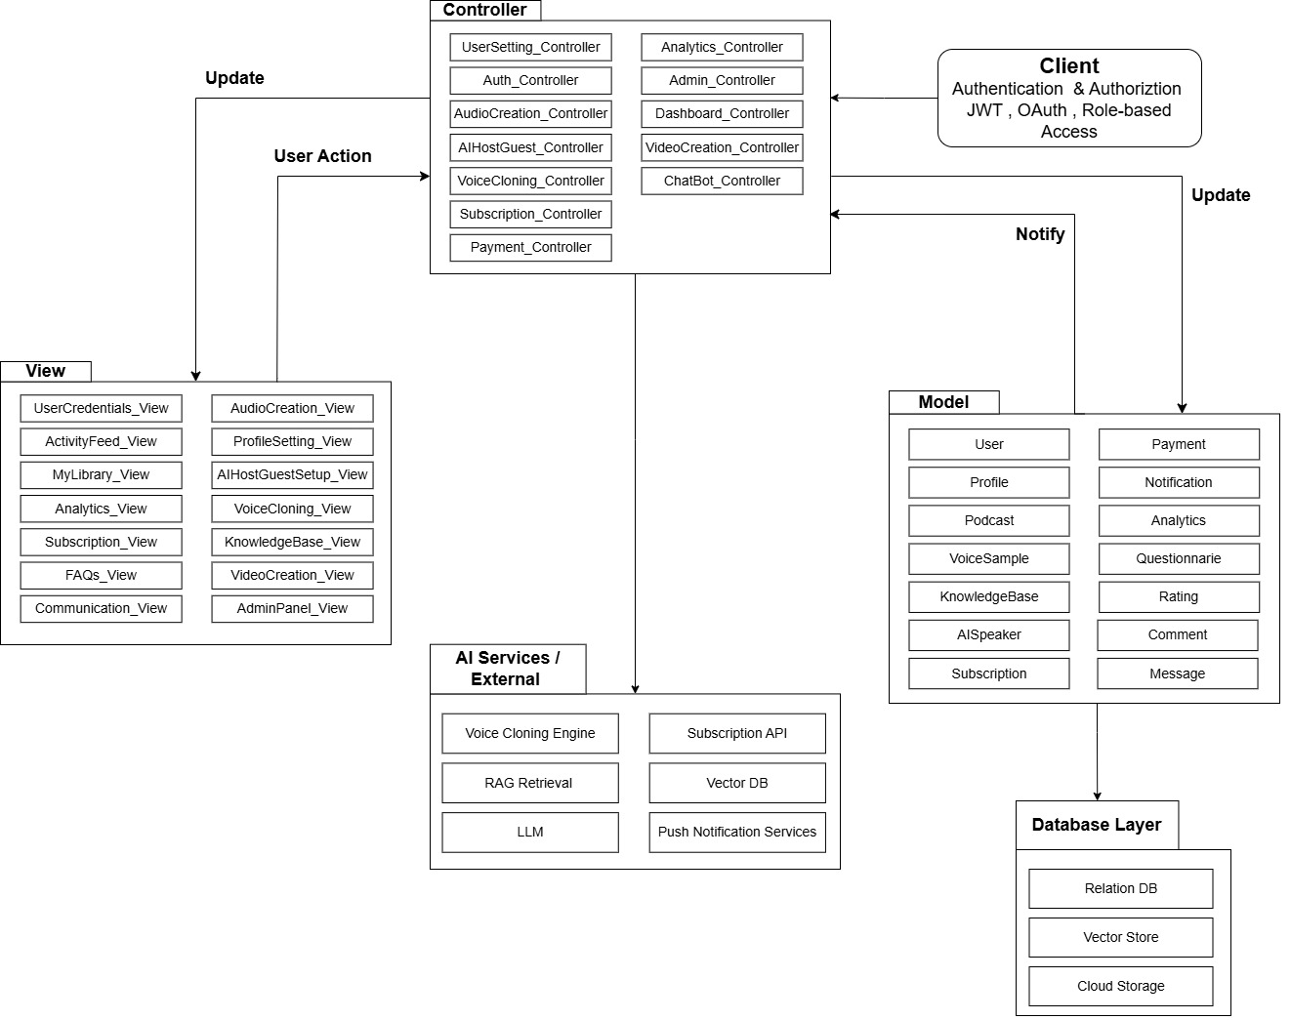

Figure 4.1: Architecture Diagram for PodVerse

Design Models
This section shows the design models for the system.

Activity Diagrams

Register Account
This diagram shows the workflow of the user registration process, from entering details to account creation and email verification.

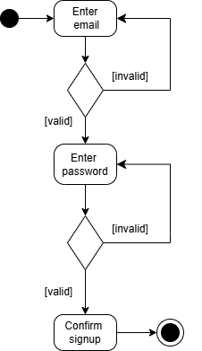

Figure 4.2: Activity Diagram for Sign up

Login
This diagram explains the steps involved when a user logs into PodVerse using email and password.
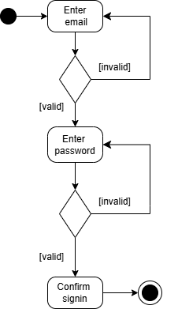

Figure 4.3: Activity Diagram for Sign in

Edit Profile
This diagram shows how users update their personal information and save changes to their profile.

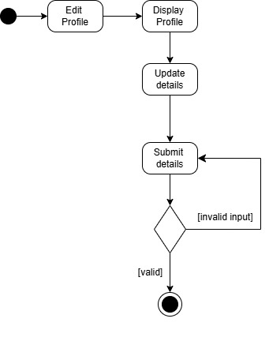
Figure 4.4: Activity Diagram for Edit Profile

Voice Cloning
This diagram illustrates the steps for uploading/recording voice samples and generating a cloned voice.

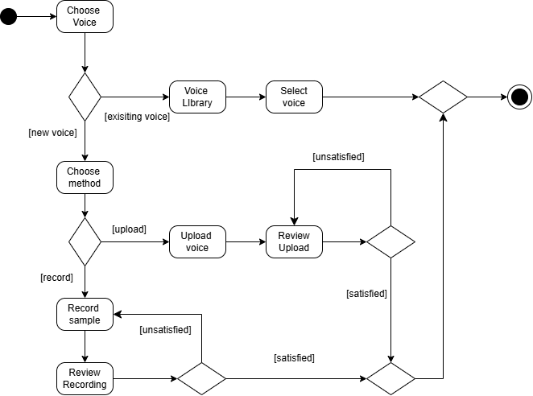

Figure 4.5: Activity Diagram for Voice Cloning

Knowledge Base Setup
This diagram shows how users upload, process, and store knowledge base files for RAG retrieval.

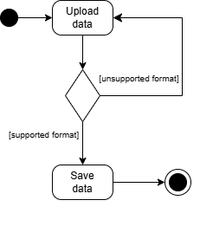

Figure 4.6: Activity Diagram for Knowledge Base Setup

AI Speaker Customization
This diagram explains how users customize an AI agent’s voice, name, and avatar.

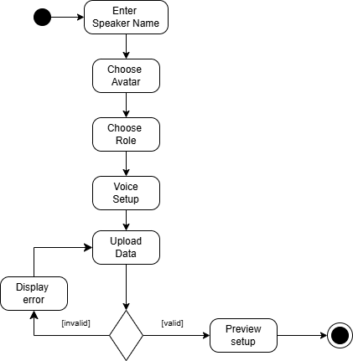

Figure 4.7: Activity Diagram for AI Speaker Customization

Podcast Audio Creation
This diagram outlines how users record conversations with the AI agent and generate podcast audio.

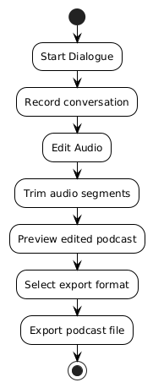

Figure 4.8: Activity Diagram for Podcast Audio Creation

Podcast Video Creation
This diagram shows how users select avatars, sync audio, and export podcast videos.

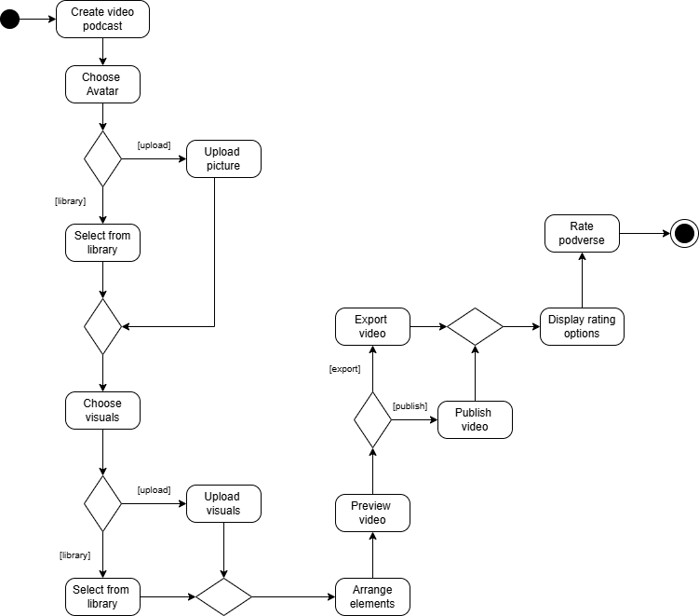

Figure 4.9: Activity Diagram for Podcast Video Creation

Request Podcast Summary

This diagram explains how users request an AI-generated summary of any podcast episode.
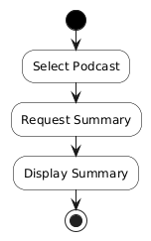

Figure 4.10: Activity Diagram for Podcast Summary

FAQs Chatbot
This diagram illustrates how the system processes user queries and fetches relevant answers from the FAQs database.
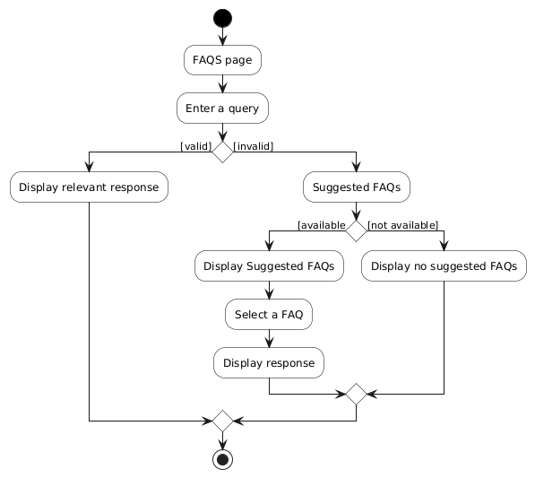

Figure 4.11: Activity Diagram for FAQs Chatbot

Manage Users
This diagram explains how the admin monitors, updates, and manages user accounts.

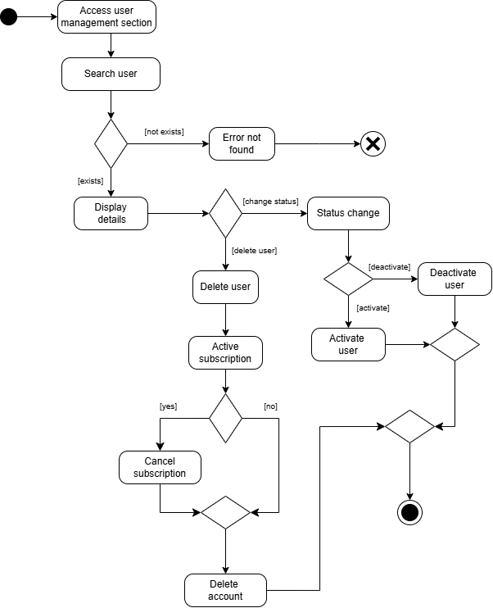

Figure 4.12: Activity Diagram for Managing Users

Logout
This diagram shows how the system handles secure user logouts.

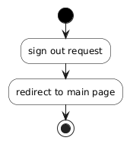

Figure 4.13: Activity Diagram for Sign out

Class Diagram

This diagram presents the system’s classes, their attributes, relationships, and how different modules interact in PodVerse.

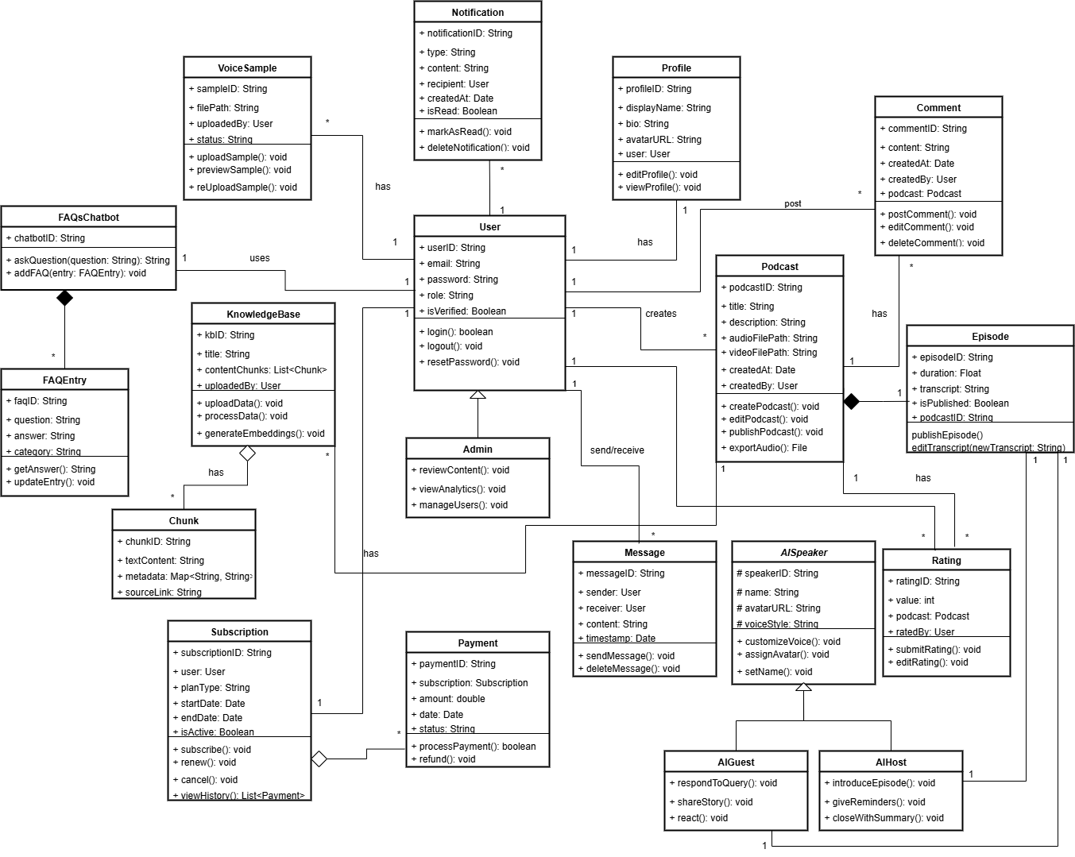

Figure 4.14: Class Diagram for PodVerse

Sequence Diagrams
Following are the sequence diagrams of PodVerse:

Module 1: User Authentication

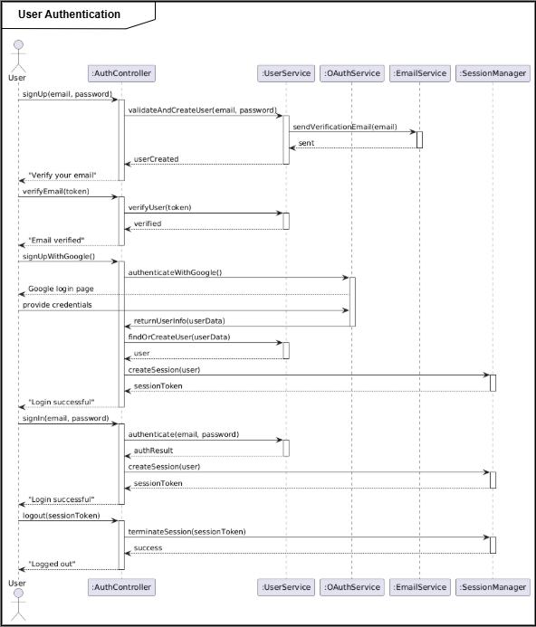
This diagram shows how users authenticate using email and password, and how the system validates credentials.
Figure 4.15: Sequence diagram of module 1

Module 2: Voice Cloning

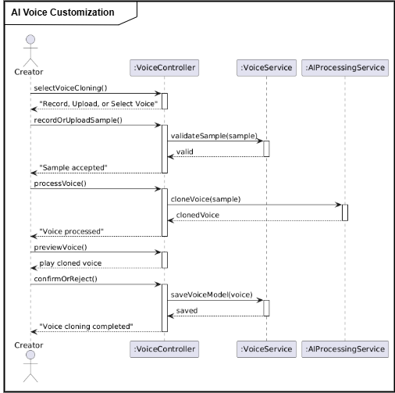
This diagram explains the communication between user, voice engine, and storage during voice cloning.

Figure 4.16: Sequence diagram of module 2

Module 3: Knowledge Base Setup

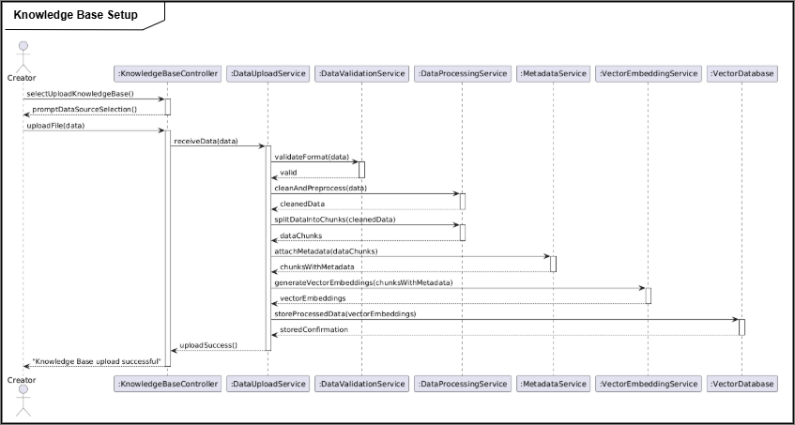
This diagram shows how knowledge base files are uploaded, processed, chunked, and stored.

Figure 4.17: Sequence diagram of module 3

Module 4: RAG Retrieval

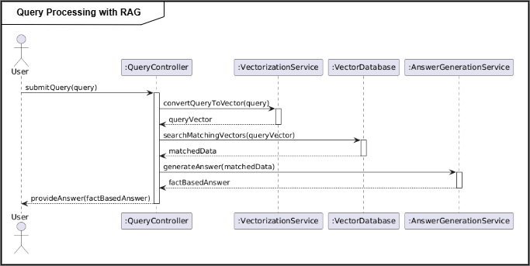
This diagram presents the RAG query process, including embedding generation, retrieval, and response creation.

Figure 4.18: Sequence diagram of module 4

Module 6: Podcast Audio Creation

This diagram explains the flow of recording audio, generating AI responses, and saving podcast audio.
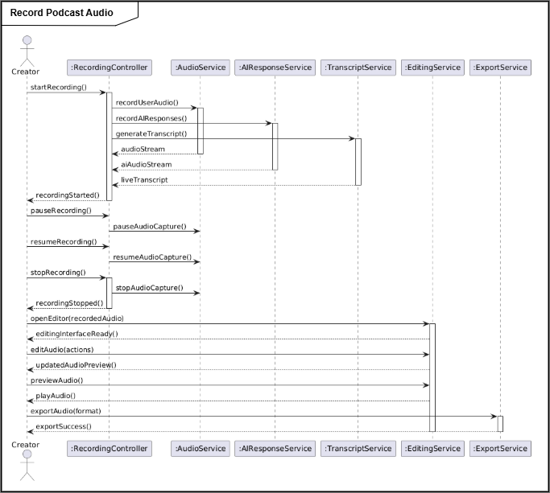

Figure 4.19: Sequence diagram of module 6

Module 9: Podcast Video Creation and Publishing

This diagram shows how avatars, audio sync, templates, and video export processes interact for final video output.
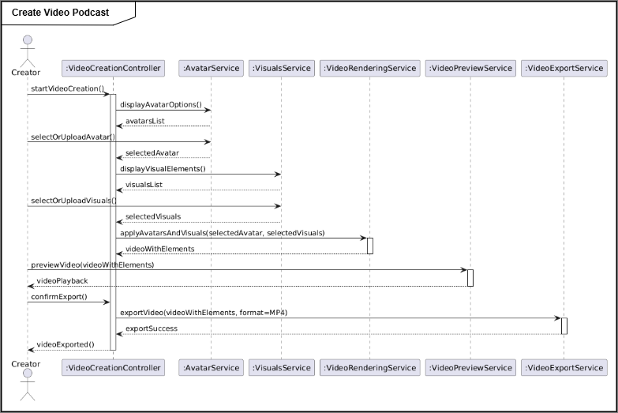

Figure 4.20: Sequence diagram of module 9

Module 10: FAQs Chatbot

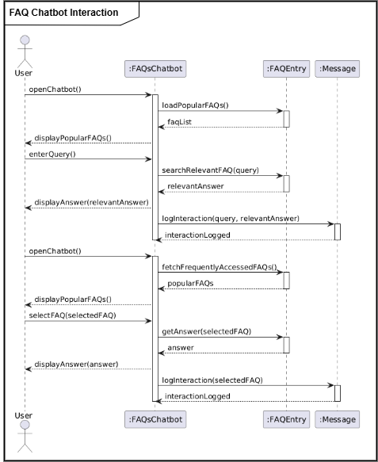
This diagram shows how the chatbot receives questions, retrieves FAQ content, and returns answers.

Figure 4.21: Sequence diagram of module 11

Module 11: Audience Engagement

This diagram illustrates how notifications, messaging, and engagement features interact with system backend.
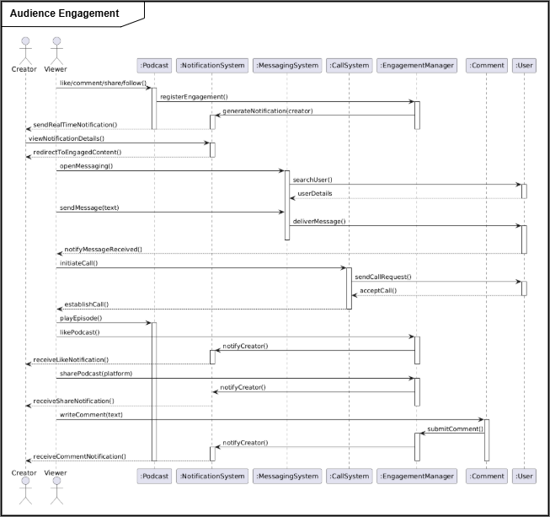

Figure 4.22: Sequence diagram of module 12

Module 12: Admin Panel and Analytics

This diagram presents how the admin panel manages users, monitors activities, and retrieves analytics data.
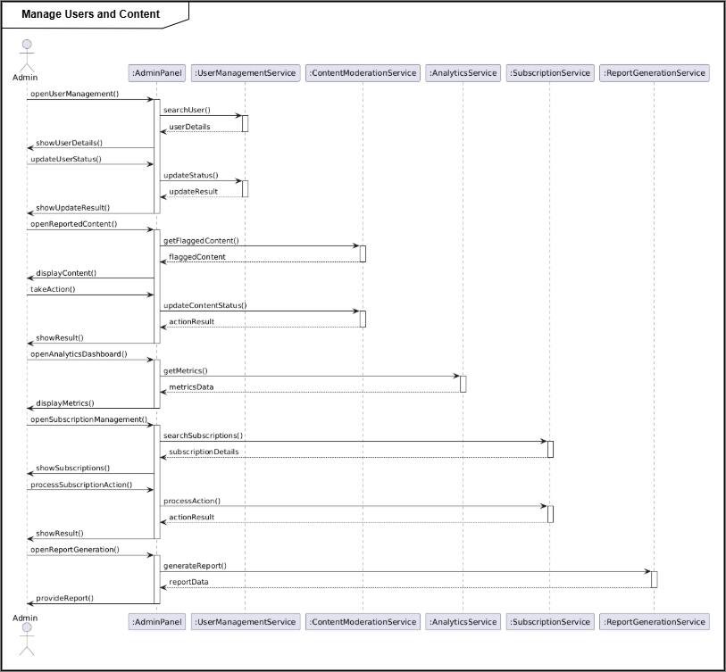

Figure 4.23: Sequence diagram of module 13

State Transition Diagrams
The following are the state transition diagrams of the backend processes of our system:

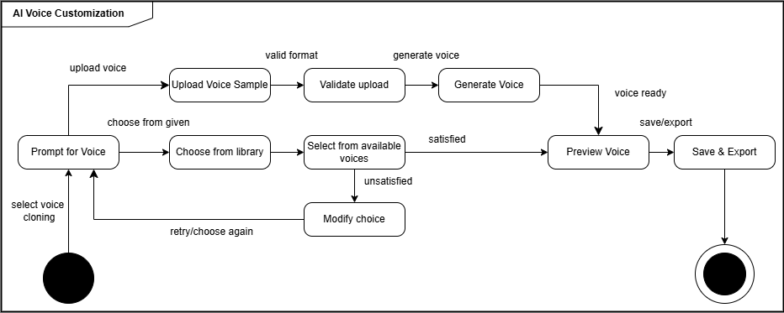
This diagram shows how the AI agent transitions between different states during voice customization.

Figure 4.24: State transition diagram of AI Voice Customization

This diagram explains the states from file upload to processing, chunking, and final storage.
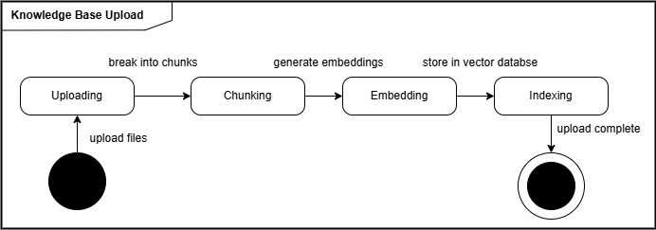
Figure 4.25: State transition diagram of Knowledge Base Upload

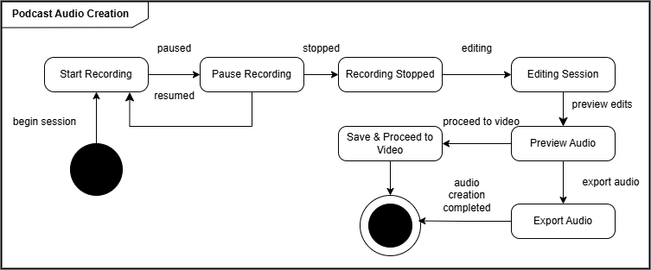
This diagram illustrates the transitions between recording, processing, editing, and saving podcast audio.

Figure 4.26: State transition diagram of Podcast Audio Creation

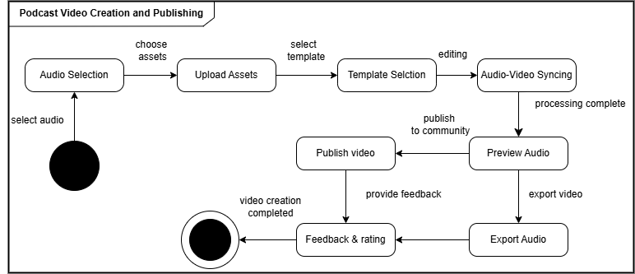
This diagram outlines the states involved in generating video, applying templates, syncing audio, and publishing the final output.

Figure 4.27: State transition diagram of Podcast Video Creation and Publishing

Data Design
The data design of PodVerse is as follows:

Data Dictionary
Following is the data dictionary of PodVerse:

User Collection
CREATE TABLE users (
id UUID PRIMARY KEY DEFAULT uuid_generate_v4(),
full_name TEXT,
email TEXT UNIQUE NOT NULL,
password_hash TEXT NOT NULL,
is_verified BOOLEAN DEFAULT FALSE,
otp TEXT,
provider TEXT DEFAULT 'email' CHECK (provider IN ('email', 'google')),
reset_password_token TEXT,
reset_password_expires TIMESTAMP,
profile_url TEXT DEFAULT 'https://example.com/default-profile.png',
created_at TIMESTAMP DEFAULT NOW()
);
Table 4.1: Data Collection of ‘User’

Field Name | Data Type | Constraints | Description
id | UUID | Primary Key | Unique user identifier
full_name | Text | None | User’s full name
email | Text | Unique, Not Null | User’s email address
password_hash | Text | Not Null | Hashed password
is_verified | Boolean | Default: false | Email verification status
otp | Text | None | One-Time Password for verification
provider | Text | Enum: email/google | Authentication provider
reset_password_token | Text | None | Token for password reset
reset_password_expires | Timestamp | None | Token expiry time
profile_url | Text | Default URL | User profile image
created_at | Timestamp | Default: now() | Account creation timestamp

Podcast Collection
CREATE TABLE podcasts (
podcast_id UUID PRIMARY KEY DEFAULT uuid_generate_v4(),
created_by UUID REFERENCES users(id),
title TEXT NOT NULL,
description TEXT,
category TEXT,
video_file_path TEXT,
transcript TEXT,
cover_image_url TEXT,
created_at TIMESTAMP DEFAULT NOW()
);
Table 4.2: Data Collection of ‘Podcast’

Field Name | Data Type | Constraints | Description
podcast_id | UUID | Primary Key | Unique podcast identifier
created_by | UUID | Foreign Key | Linked user ID (creator)
title | Text | Not Null | Podcast title
description | Text | None | Description of the podcast
category | Text | None | Genre/category
video_file_path | Text | None | URL of uploaded podcast video
transcript | Text | None | Auto-generated transcript
cover_image_url | Text | None | Podcast cover/thumbnail
created_at | Timestamp | Default: now() | Creation timestamp

Voice Sample Collection
CREATE TABLE voice_samples (
sample_id UUID PRIMARY KEY DEFAULT uuid_generate_v4(),
uploaded_by UUID REFERENCES users(id),
sample_audio_url TEXT,
clone_model_id TEXT,
created_at TIMESTAMP DEFAULT NOW());
Table 4.3: Data Collection of ‘Voice Sample’

Field Name | Data Type | Constraints | Description
sample_id | UUID | Primary Key | Unique sample ID
uploaded_by | UUID | Foreign Key | User who uploaded the voice sample
sample_audio_url | Text | None | URL of uploaded audio sample
clone_model_id | Text | None | ID of trained clone model
created_at | Timestamp | Default: now() | Upload timestamp

Knowledge Base Collection
CREATE TABLE knowledge_base (
id UUID PRIMARY KEY DEFAULT uuid_generate_v4(),
user_id UUID REFERENCES users(id),
title TEXT,
source_type TEXT,
chunk TEXT,
file_id TEXT,
uploaded_at TIMESTAMP DEFAULT NOW());

Table 4.4: Data Collection of ‘Knowledge Base’

Field Name | Data Type | Constraints | Description
id | UUID | Primary Key | Unique knowledge base ID
user_id | UUID | Foreign Key | Linked user ID
title | Text | None | Name of uploaded knowledge item
source_type | Text | None | Type (PDF, URL, etc.)
chunk | Text | None | Extracted content chunk
file_id | Text | None | Reference to original file
uploaded_at | Timestamp | Default: now() | Upload timestamp

AI Speaker Collection
CREATE TABLE ai_speakers (
speaker_id UUID PRIMARY KEY DEFAULT uuid_generate_v4(),
user_id UUID REFERENCES users(id),
name TEXT NOT NULL,
language TEXT NOT NULL,
voice_style TEXT,
avatar_url TEXT,
is_host BOOLEAN,
created_at TIMESTAMP DEFAULT NOW()
);
Table 4.5: Data Collection of ‘AI Speaker’

Field Name | Data Type | Constraints | Description
speaker_id | UUID | Primary Key | AI speaker ID
user_id | UUID | Foreign Key | Linked user
name | Text | Not Null | AI speaker name
language | Text | Not Null | Spoken language
voice_style | Text | Nullable | Style (Calm, Energetic, etc.)
avatar_url | Text | Nullable | Avatar/3D model link

Notification Collection
CREATE TABLE notifications (
notification_id UUID PRIMARY KEY DEFAULT uuid_generate_v4(),
user_id UUID REFERENCES users(id),
title TEXT,
message TEXT,
is_read BOOLEAN DEFAULT FALSE,
created_at TIMESTAMP DEFAULT NOW()
);
Table 4.6: Data Collection of ‘Notification’

Field Name | Data Type | Constraints | Description
notificationID | String | Primary Key | Unique notification ID
userID | String | Foreign Key | Recipient user ID
title | String | None | Title of the notification
message | String | None | Main content of the notification
createdAt | DateTime | None | Timestamp of the notification
isRead | Boolean | Default: false | Read/unread status

FAQs Chatbot Collection
CREATE TABLE faq_bots (
bot_id UUID PRIMARY KEY DEFAULT uuid_generate_v4(),
user_id UUID REFERENCES users(id),
bot_name TEXT,
description TEXT,
created_at TIMESTAMP DEFAULT NOW()
);
Table 4.7: Data Collection of ‘FAQs Chatbot’

Field Name | Data Type | Constraints | Description
chatbotID | String | Primary Key | Unique chatbot session ID
userID | String | Foreign Key | User who started the session
sessionStart | DateTime | Not Null | When the session began
sessionEnd | DateTime | Nullable | When the session ended

FAQs Entry Collection
CREATE TABLE faq_entries (
faq_id UUID PRIMARY KEY DEFAULT uuid_generate_v4(),
bot_id UUID REFERENCES faq_bots(bot_id),
question TEXT NOT NULL,
answer TEXT NOT NULL,
category TEXT,
created_at TIMESTAMP DEFAULT NOW()
);

Table 4.8: Data Collection of ‘FAQs Entry’

Field Name | Data Type | Constraints | Description
faqID | String | Primary Key | Unique ID of the FAQ entry
question | String | Not Null | FAQ question
answer | Text | Not Null | FAQ answer
category | String | Nullable | Category (e.g., Billing, Technical, General)
createdAt | DateTime | Not Null | Entry creation timestamp

Comment Collection
CREATE TABLE comments (
comment_id UUID PRIMARY KEY DEFAULT uuid_generate_v4(),
user_id UUID REFERENCES users(id),
episode_id UUID REFERENCES podcasts(podcast_id),
content TEXT NOT NULL,
created_at TIMESTAMP DEFAULT NOW(),
updated_at TIMESTAMP
);
Table 4.9: Data Collection of ‘Comment’

Field Name | Data Type | Constraints | Description
commentID | String | Primary Key | Unique identifier for the comment
userID | String | Foreign Key | User who made the comment
episodeID | String | Foreign Key | Episode the comment is associated with
content | Text | Not Null | The actual comment text
createdAt | DateTime | Not Null | Timestamp when the comment was created
updatedAt | DateTime | Nullable | Timestamp when the comment was last edited

Rating Collection
CREATE TABLE ratings (
rating_id UUID PRIMARY KEY DEFAULT uuid_generate_v4(),
user_id UUID REFERENCES users(id),
episode_id UUID REFERENCES podcasts(podcast_id),
score INTEGER NOT NULL CHECK (score BETWEEN 1 AND 5),
comment TEXT,
created_at TIMESTAMP DEFAULT NOW()
);
Table 4.10: Data Collection of ‘Rating’

Field Name | Data Type | Constraints | Description
ratingID | String | Primary Key | Unique identifier for the rating
userID | String | Foreign Key | User who gave the rating
episodeID | String | Foreign Key | Episode that was rated
score | Integer | Not Null | Rating score (e.g., 1 to 5)
comment | String | Nullable | Optional comment/review associated with the rating
createdAt | DateTime | Not Null | When the rating was submitted

Implementation
This section contains the implementation details of the system. It includes algorithms, external APIs used by the system, user interface design and deployment details.

Algorithm

The following are the algorithms used in PodVerse:
Algorithm 1 Voice Cloning | Algorithm 2 RAGBasedAIConversation
Input: User's audio sample (.wav) | Input: audio_file, user_id
Output: Cloned voice model ID | Output: response_audio_path, answer_text
1: Import required libraries (TTS.api.TTS, os, torch, functools)  2: Override torch.load to prevent weight-only loading issues  3: original_load ← torch.load  4: torch.load ← lambda *args, **kwargs: original_load(*args, **kwargs, weights_only=False)  5: Check for GPU availability  6: use_gpu ← torch.cuda.is_available()  7: Print "GPU acceleration enabled/disabled" based on use_gpu  8: Load XTTS v2 model using Coqui TTS API  9: tts ← TTS("tts_models/multilingual/multi-dataset/xtts_v2", gpu=use_gpu, progress_bar=False)  10: Function clone_voice(text_input, speaker_paths, output_path):  11: Call tts.tts_to_file with the following parameters:  12: text ← text_input  13: speaker_wav ← speaker_paths (list of WAV file paths)  14: file_path ← output_path  15: split_sentences ← True  16: language ← "en"  17: This generates cloned voice audio and saves it to output_path | 1: Import required libraries (SpeechRecognition, Whisper, FAISS, HuggingFaceEmbeddings, ChatOpenAI, gTTS)  2: Function transcribe_audio(audio_file):  3: Save audio_file temporarily  4: Convert to WAV using FFmpeg  5: Load audio into recognizer  6: Try:  7: Transcribe audio using Google Speech Recognition or Whisper  8: Return transcribed_text  9: Except transcription error:  10: Return "Could not understand audio"  11: Function retrieve_user_knowledge(user_id):  12: Query MongoDB `knowledge_base` for chunks where user_id = input user_id  13: Convert chunks to LangChain Document format  14: Generate FAISS vector store using HuggingFaceEmbeddings  15: Return retriever  16: Function generate_ai_response(query_text, retriever):  17: Define custom PromptTemplate (friendly tone, context-aware)  18: Initialize RetrievalQA with LLM (ChatOpenAI) and retriever  19: Invoke QA chain with query_text  20: Return answer_text and source_documents  21: Function synthesize_audio(answer_text, user_id):  22: Use gTTS to synthesize answer_text into MP3  23: Save as "response_userid.mp3"  24: Return audio_file_path  25: Main Function handle_audio_conversation(audio_file, user_id):  26: transcribed_text ← transcribe_audio(audio_file)  27: If transcribed_text is empty or error:  28: Return error message  29: retriever ← retrieve_user_knowledge(user_id)  30: answer_text, sources ← generate_ai_response(transcribed_text, retriever)  31: audio_file_path ← synthesize_audio(answer_text, user_id)  32: Return audio_file_path, answer_text, sources
Algorithm 3 Audio Transcription
Input: tuser_id, audio_file (uploaded audio file)
Output: Transcribed text of the audio OR error message
- Start transcription process.
- Receive user_id and audio_file from the client.
- Save the uploaded audio as a temporary file on the server.
- Filename: temp_<original_filename>
- Check if audio file is empty:
- If file size is 0 bytes, return "Uploaded audio file is empty".
- Convert audio file to WAV format (16kHz, mono) using FFmpeg:
- Input: uploaded audio file
- Output: converted.wav
- If FFmpeg conversion fails, return the error.
- Load converted.wav using speech_recognition.AudioFile.
- Record the audio data from the WAV file.
- Transcribe using Google Speech Recognition:
- If speech is recognized successfully, proceed.
- If speech is not understood, return "Could not understand audio".
- If any exception occurs, return the error.
- Delete temporary files (temp_<original_filename>, converted.wav).
- Return the transcribed text in JSON response.

Algorithm 4: Video Generation (Podcast Video Creation & Publishing)
Input: audio_file, speaker_avatars, selected_template
Output: Final video file (.mp4)
1. Import required libraries (Remotion, ffmpeg, video_template_engine).

2. Function load_assets():
3. Load selected avatars, backgrounds, and visual elements.
4. Load audio_file for lip-sync and waveform.

5. Function extract_timestamps(audio_file):
6. Use speech-to-text or silence detection to determine speech segments.
7. Return timestamp list for avatar mouth movements.

6. Function generate_lipsync(avatar, timestamps):
7. Map timestamps to mouth animation frames.
8. Return animated avatar frames.

7. Function apply_template(template, avatar_frames, background):
8. Render layout based on template (e.g., split-screen, studio view).
9. Combine avatars, text, backgrounds, and motion effects.
10. Return composite frames.

11. Function assemble_video(frames, audio_file):
12. Use FFmpeg to merge:
13. - Rendered frames
14. - Audio track
15. - Frame rate settings
16. Export final video as MP4.

17. Main generate_video():
18. assets ← load_assets()
19. timestamps ← extract_timestamps(audio_file)
20. avatar_frames ← generate_lipsync(avatars, timestamps)
21. frames ← apply_template(selected_template, avatar_frames)
22. final_video ← assemble_video(frames, audio_file)
23. Return final_video path.

External APIs/SDKs

Table 52: Details of APIs used in the project

Name of API and version | Description of API | Purpose of usage | List down the API endpoints
Supabase | Backend-as-a-Service providing authentication, database, and storage | Used for user authentication, managing podcast data, and storing user information | https://<project>.supabase.co/auth/v1

User Interface

SignIn

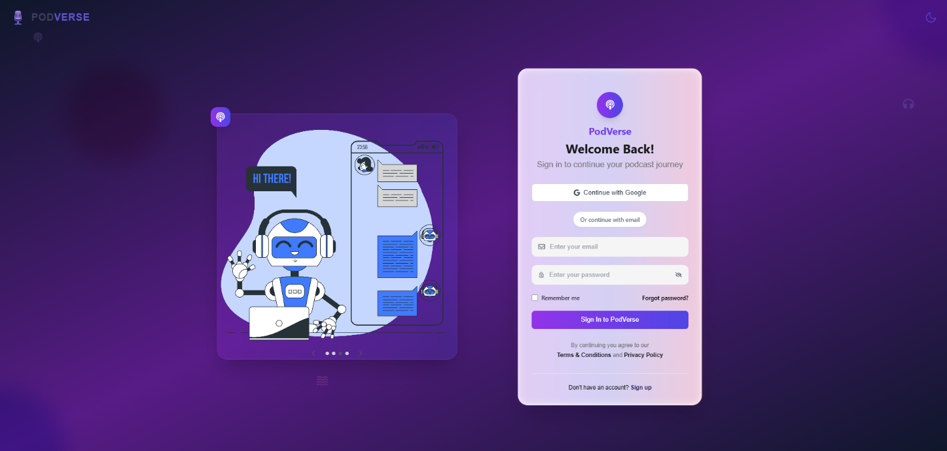

Library
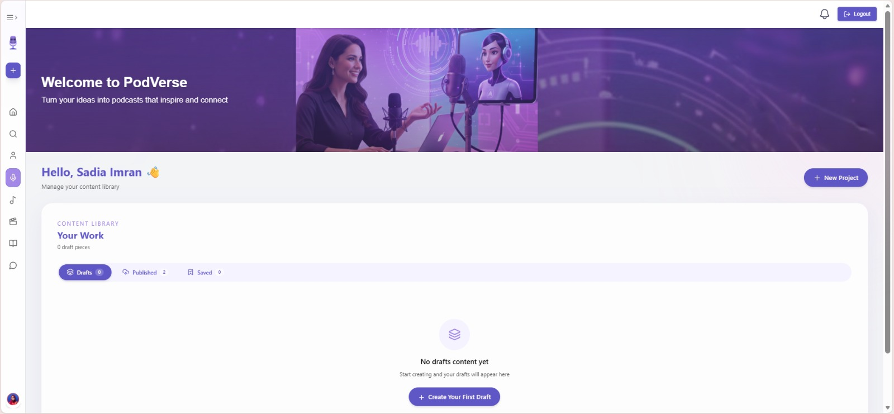

Home Page

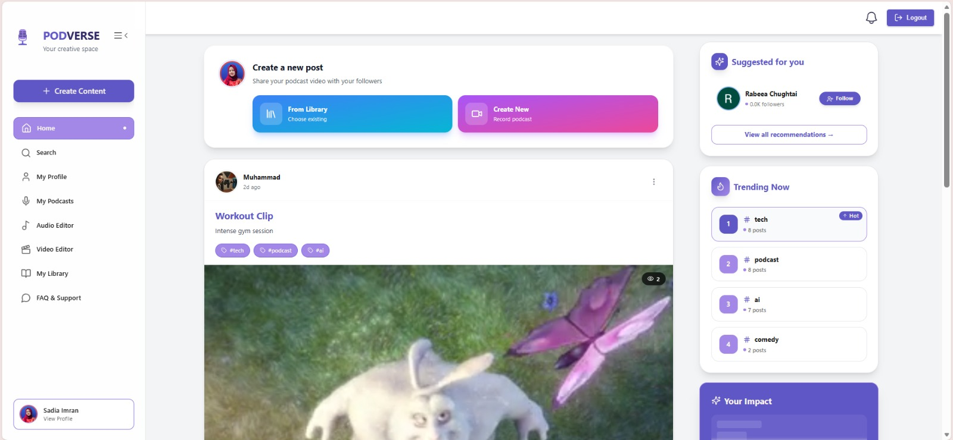

Profile

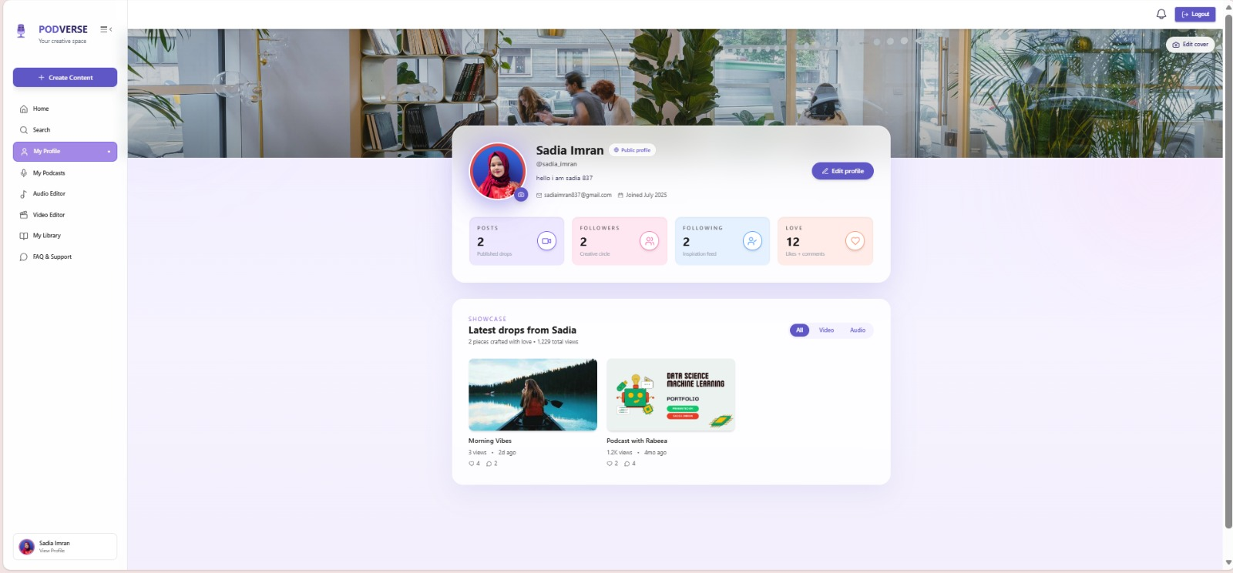

Speaker Customization

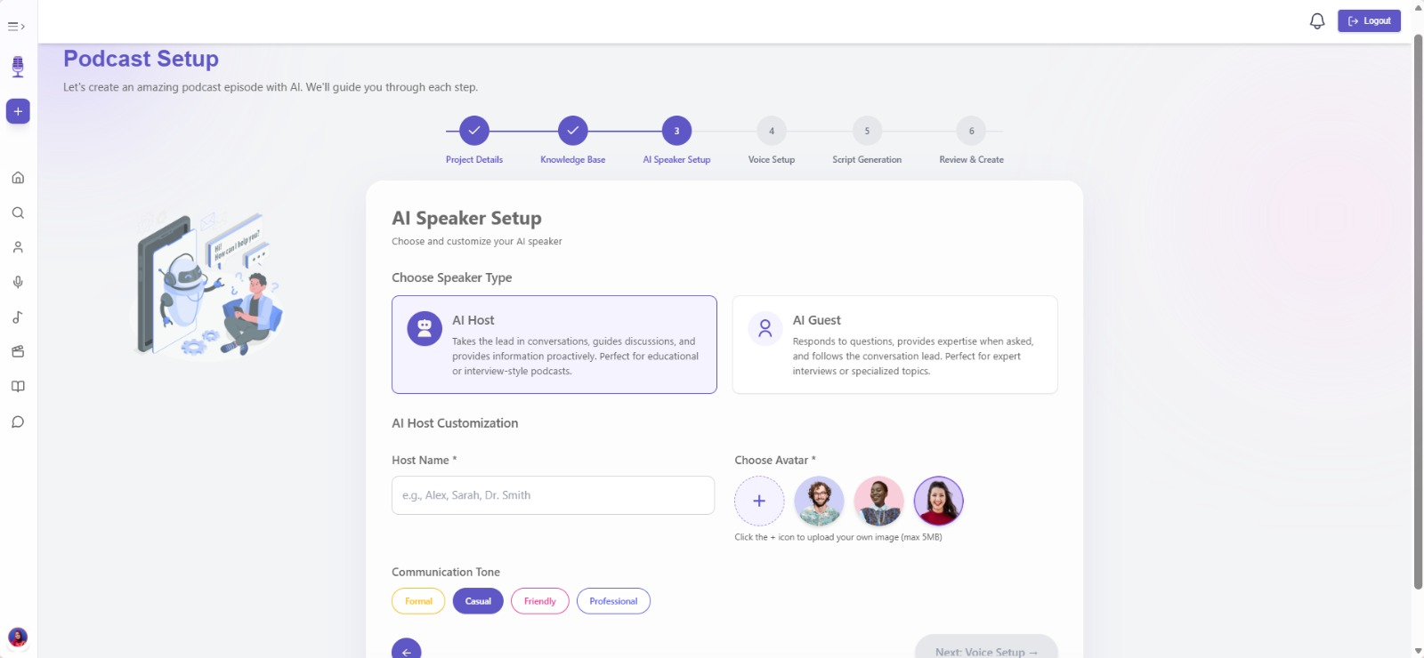

Voice Customization

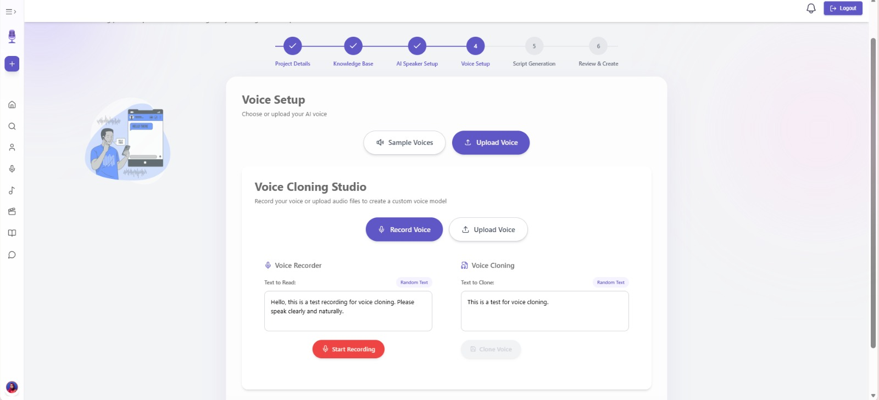

Recording Studio

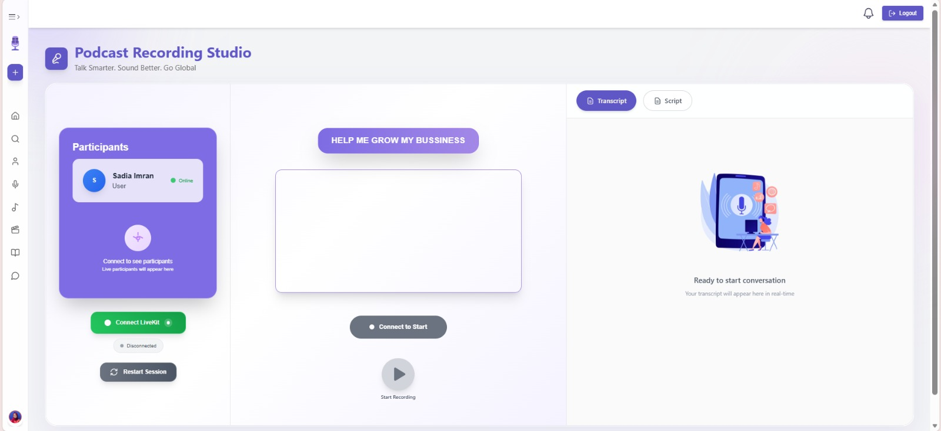

Audio Editing Panel
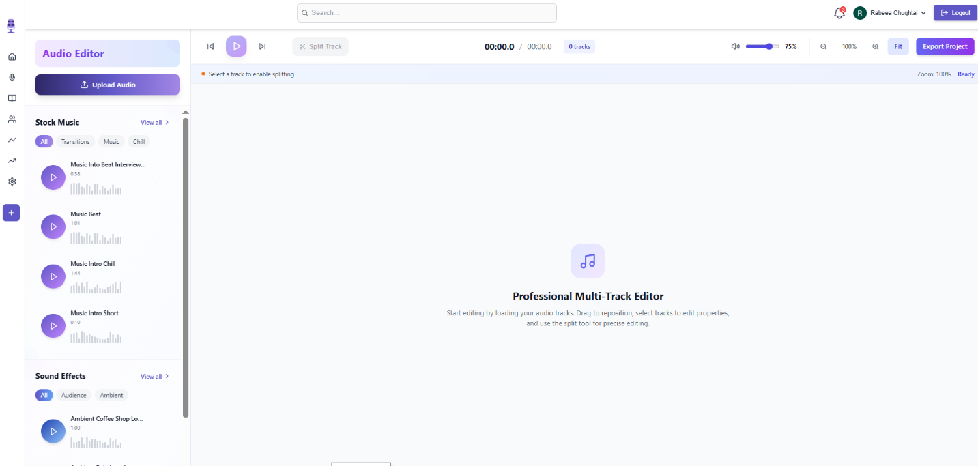

Video Generation
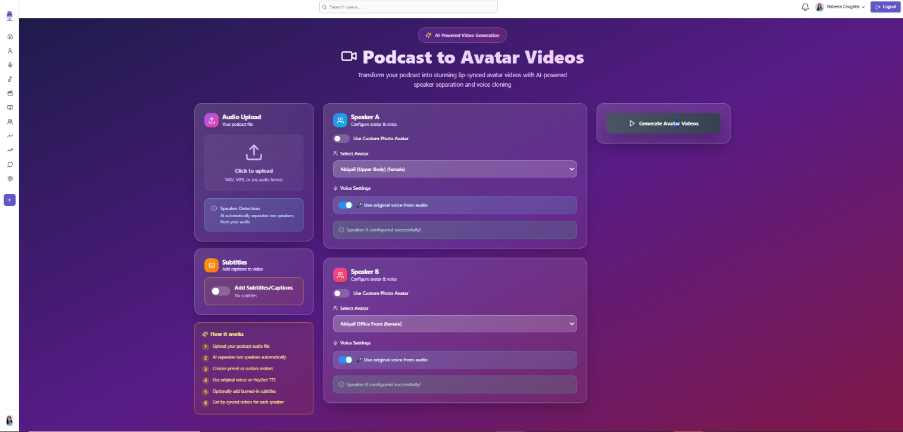

Video Editing Panel
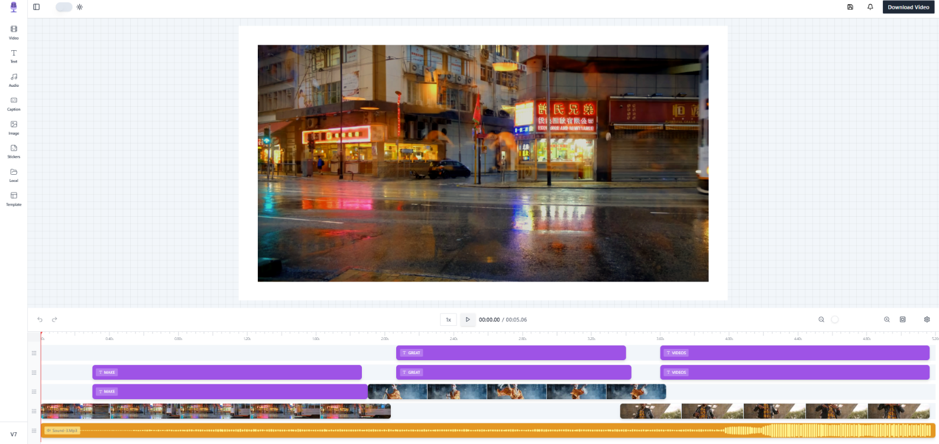

Admin Dashboard
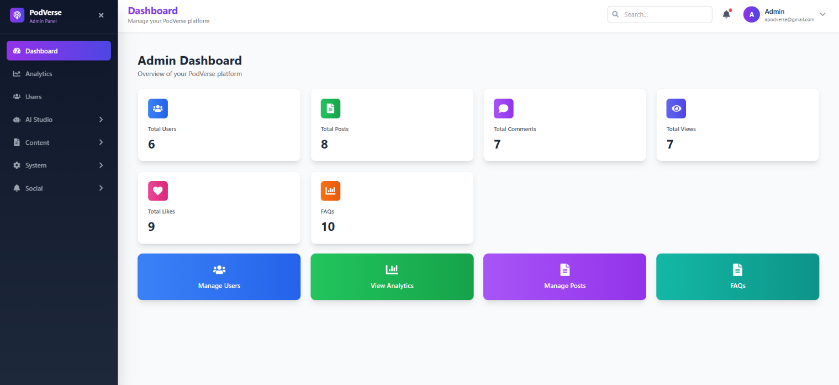

Testing and Evaluation

This section includes unit testing, functional testing, and integration testing details for the modules we have developed so far. The purpose of unit testing is to ensure that each component of the software functions as intended.

Unit Testing
This section has the unit level test cases for PodVerse system:

Unit Testing 1: Email Validation Function

Table 6.1: Unit Test Cases for Email Validation Function

No. | Test Script | Input | Expected Output | Result
1 | validateEmailFormat | Email: abc@gmail.com | true | Pass
2 | validateEmailFormat | Email: abc.gmail.com | false | Pass
3 | validateEmailFormat | Email: `` (empty) | false | Pass

Unit Testing 2: checkEmailExists()

Table 6.2: Unit Test Cases to Check Email Exists

No. | Test Case/Test Script | Attribute and Value | Expected Result | Result
1 | checkEmailExists | Email: sadiaimran837@gmail.com, Password: Sadia@123 | true | Pass
2 | checkEmailExists | Email: sadiaimran837@gmail.com | Error: "Email already exists" | Pass

Unit Testing 3: Password Encryption & Verification

Table 6.3: Unit Test Cases for Password Encryption & Verification

No. | Test Script | Input | Expected Output | Result
1 | encryptPassword() | Input: Test123! | Encrypted string returned | Pass
2 | verifyPassword() | Input: Test123!, Hash | true | Pass
3 | verifyPassword() | Input: WrongPass, Hash | false | Pass

Unit Testing 4: OTP Generator & Validator

Table 6.4: Unit Test Cases for OTP Generator & Validator

No. | Test Script | Input | Expected Output | Result
1 | generateOTP() | Triggered | 6-digit numeric OTP | Pass
2 | verifyOTP() | Input: 123456, Match | success | Pass
3 | verifyOTP() | Input: 999999, Mismatch | failure | Pass

Unit Testing 5: Voice Cloning File

Table 6.5: Unit Test Cases for Voice Cloning File

No. | Test Script | Input | Expected Output | Result
1 | processVoiceSample() | File: voice.wav | Cleaned mono audio | Pass
2 | extractVoiceProfile() | Cleaned audio | Voice profile (speaker vector) generated | Pass
3 | saveVoiceProfile() | Profile data, user ID | Voice profile linked to user in database | Pass

Unit Testing 6: Summarization

Table 6.6: Unit Test Cases for Summarization

No. | Test Script | Input | Expected Output | Result
1 | generateSummary() | Text: 1000 words | Summary ≤ 150 words | Pass
2 | generateSummary() | Input: `` (empty) | Error: Missing transcript | Pass
3 | saveSummaryToDB() | Summary, transcript_id | MongoDB write success | Pass

Unit Testing 7: Transcription Module

Table 6.7: Unit Test Cases for Transcription Module

No. | Test Case | Attribute and Value | Expected Result | Result
1 | preprocessAudio() | .wav file | Cleaned 16kHz audio path | Pass
2 | transcribeAudio() | Cleaned audio | Transcript string | Pass
3 | saveTranscriptToDB() | Transcript, podcast_id | MongoDB write success | Pass

Unit Testing 8: AI-Conversation Reply Generator

Table 6.8: Unit Test Cases for AI-Conversation Reply Generator

No. | Test Script | Input | Expected Output | Result
1 | generateReplyFromText() | Transcript: "Tell me something" | String reply from AI | Pass
2 | saveToConversationLog() | user_id, AI reply | DB write success | Pass

Unit Testing 9: AI Speaker Customization

Table 6.9: Unit Test Cases for AI Speaker Customization

No. | Test Case/Test Script | Attribute and Value | Expected Result | Result
1 | Upload valid avatar image | File: avatar.png | Image preview displayed, file saved | Pass
2 | Upload unsupported avatar file | File: avatar.txt | Error: "Only PNG, JPG supported" | Pass
3 | Select speaker role | Option: AI Guest | Role saved in session | Pass
4 | Upload valid knowledge base | File: kb_text.pdf | Text extracted and saved | Pass
5 | Upload unsupported knowledge base | File: kb.exe | Error: "Invalid file format" | Pass
6 | Save speaker config | Role + Avatar + KB | MongoDB profile updated | Pass

Unit Testing 10: Audio Recorder Module

Table 6.10: Unit Test Cases for Audio Recorder Module

No. | Test Script | Input | Expected Output | Result
1 | startRecording() | Trigger | Mic access granted | Pass
2 | stopRecording() | File path | Audio saved | Pass
3 | uploadToFirebase() | File: audio.wav | URL returned | Pass

Unit Testing 11: Knowledge Base Processing

Table 6.11: Unit Test Cases for Knowledge Base Processing

No. | Test Case/Test Script | Attribute and Value | Expected Result | Result
1 | Upload valid .txt file | File: facts.txt | Text content extracted and saved | Pass
2 | Upload valid .pdf file | File: data.pdf | Text extracted from PDF | Pass
3 | Upload corrupted file | File: bad.pdf | Error: "Unable to read file content" | Pass
4 | Link content to speaker config | Speaker ID: ai_6123abc | MongoDB updated with knowledge source | Pass

Functional Testing
The following are the functional test cases of PodVerse:

Functional Testing 1: SignUp & OTP Verification

Table 6.12: Functional Test Cases for SignUp & OTP Verification

No. | Test Case/Test Script | Attribute and Value | Expected Result | Actual Result | Result
1 | Register with valid details | Email: sadiaimran837@gmail.com, Password: Sadia@123 | OTP sent to registered email | OTP screen appeared, email received | Pass
2 | Duplicate email | Email: sadiaimran837@gmail.com | Error: "Email already in use" | Error message displayed | Pass

Functional Testing 2: Login

Table 6.13: Functional Test Cases for Login

No. | Test Case/Test Script | Attribute and Value | Expected Result | Actual Result | Result
1 | Valid login credentials | Email: rabeeachughtai1@gmail.com, Password: Rabeea@123 | Dashboard loaded | User redirected to dashboard | Pass
2 | Incorrect password | Email: rabeeachughtai1@gmail.com, Password: Wrong123 | Error: "Invalid credentials" | Error toast displayed | Pass

Functional Testing 3: Podcast Transcription

Table 6.14: Functional Test Cases for Podcast Transcription

No. | Test Case/Test Script | Attribute and Value | Expected Result | Actual Result | Result
1 | Upload podcast audio | File: podcast.wav | Full transcript displayed on screen | Transcript text loaded in textarea | Pass
2 | Upload empty or silent file | File: silence.wav | Error: “No speech detected” | Warning shown in toast | Pass

Functional Testing 4: Voice Cloning

Table 6.15: Functional Test Cases for Voice Cloning

No. | Test Case/Test Script | Attribute and Value | Expected Result | Actual Result | Result
1 | Upload valid voice sample | File: user_voice.wav | Voice cloned successfully, stored for reuse | “Voice cloned” message shown | Pass
2 | Upload unsupported format | File: user_voice.mp3 | Error: “Only WAV files are supported” | Validation error appeared | Pass

Functional Testing 5: Transcript Summarization

Table 6.16: Functional Test Cases for Transcript Summarization

No. | Test Case/Test Script | Attribute and Value | Expected Result | Actual Result | Result
1 | Generate summary | Transcript: 1000+ words | Summary displayed (≤150 words) | Short summary shown in summary tab | Pass
2 | Click summarize with empty input | Transcript: (empty) | Error: "Transcript required" | Validation toast: “Transcript empty” | Pass

Functional Testing 6: AI-User Conversation

Table 6.17: Functional Test Cases for AI-User Conversation

No. | Test Case/Test Script | Attribute and Value | Expected Result | Actual Result | Result
1 | Upload mic prompt | File: user_prompt.wav | AI reply generated and shown | Reply displayed below waveform | Pass
2 | Submit empty prompt | File: silence.wav | Error: “Please speak to continue” | “Please speak” toast shown | Pass

Functional Testing 7: Podcast Audio Recording & Upload

Table 6.18: Functional Test Cases for Podcast Audio Recording & Upload

No. | Test Case/Test Script | Attribute and Value | Expected Result | Actual Result | Result
1 | Start/Stop recording | Record → Stop clicked | Recording preview generated | Waveform rendered | Pass
2 | Upload to Firebase | File: recorded_audio.wav | File stored, Firebase URL returned | Link received and saved | Pass
3 | Save metadata | Title: “Ep1”, Tags: [AI, Tech] | Podcast entry created in MongoDB | Metadata saved, confirmation shown | Pass

Functional Testing 8: Podcast Library Access

Table 6.19: Functional Test Cases for Podcast Library Access

No. | Test Case/Test Script | Attribute and Value | Expected Result | Actual Result | Result
1 | Load personal podcast list | User ID: rabeeachughtai1@gmail.com | User podcasts listed | Podcast cards shown on screen | Pass
2 | Play uploaded podcast | File URL from DB | Audio plays in embedded player | Media player started with audio | Pass
3 | Show sample podcasts only | Filter: sample=true | Sample podcasts displayed | Filtered list of samples shown | Pass

Functional Testing 9: AI Speaker Customization

Table 6.20: Functional Test Cases for AI Speaker Customization

No. | Test Case/Test Script | Attribute and Value | Expected Result | Actual Result | Result
1 | Upload avatar image | File: avatar.png | Avatar displayed and saved | Image shown on profile | Pass
2 | Choose speaker role | Role: AI Host | Role stored successfully | Display updated with AI Host tag | Pass
3 | Upload valid knowledge base | File: kb_notes.pdf | Text extracted and attached to AI speaker | Content linked and displayed | Pass
4 | Upload unsupported KB | File: kb.exe | Error: “Invalid file format” | Error toast: "Only PDF/TXT allowed" | Pass

Business Rules Testing
This section contains various decisions and actions according to the business rules.

Business Rules Testing 1: Only one account can be registered for a given email address

Table 6.21: Business Rules Testing 1

Conditions | Rule 1 | Rule 2 | Rule 3
Email already registered | Yes | No | No
Password valid | Yes | Yes | No
Actions
Account created | No | Yes | No

Business Rules Testing 2: Password must meet security criteria

Table 6.22: Business Rules Testing 2

Conditions | Rule 1 | Rule 2 | Rule 3
Password contains digits | Yes | No | No
Password contains letters | Yes | Yes | No
Actions
Account created | Yes | No | No

Business Rules Testing 3: Voice Cloning – Audio Upload Constraints

Table 6.23: Business Rules Testing 3

Conditions | Rule 1 | Rule 2
File format supported | Yes | No
Audio meets quality standards | Yes | Yes
Audio accepted | Yes | No
File format supported | Yes | No

Business Rules Testing 4: Knowledge Upload Format

Table 6.24: Business Rules Testing 4

Conditions | Rule 1 | Rule 2
File format supported | Yes | No
Data is structured | Yes | Yes
File accepted | Yes | No

Integration Testing
This section has the integration test cases for the modules that we have developed. They make sure that the connections and interfaces between various components of the system function correctly.

Integration Testing 1: User Registration & Email Verification

Table 6.25: Integration Testing 1 for User Registration & Email Verification

No. | Test case/ Test script | Attribute and value | Expected result | Actual result | Result
1 | Valid Registration | Email, Password, Role = "Applicant" | "Registration successful. Please verify your email." | Same | Pass
2 | Duplicate Email | Already existing email | "Email already exists" | Same | Pass
3 | Invalid Role | Role = "Manager" | "Invalid role" | Same | Pass

Integration Testing 2: Login with Verification Flow

Table 6.26: Integration Testing 2 for Login with Verification Flow

No. | Test case/ Test script | Attribute and value | Expected result | Actual result | Result
1 | Login with verified user | Email, Password | "Login successful" | Same | Pass
2 | Login with unverified user | Valid credentials | "Email not verified" | Same | Pass
3 | Incorrect password | Valid email, wrong password | "Invalid password" | Same | Pass

Integration Testing 3: Voice Cloning Flow

Table 6.27: Integration Testing 3 for Voice Cloning Flow

No. | Test case/ Test script | Attribute and value | Expected result | Actual result | Result
1 | Clone voice with valid .wav | UserID, audio_sample | "Voice cloned successfully", path | Same | Pass
2 | Upload unsupported format | .mp3 file | Error: "Unsupported format" | Same | Pass

Integration Testing 4: Podcast Transcription

Table 6.28: Integration Testing 4 for Podcast Transcription

No. | Test case/ Test script | Attribute and value | Expected result | Actual result | Result
1 | Transcribe valid podcast | Valid .wav file | Transcript returned and saved | Same | Pass
2 | Upload non-WAV file | .mp3 | Error: Invalid format or convert | Same | Pass

Integration Testing 5: Transcript Summarization

Table 6.29: Integration Testing 5 for Transcript Summarization

No. | Test case/ Test script | Attribute and value | Expected result | Actual result | Result
1 | Summarize valid transcript | 1024 token input | Summary saved in MongoDB | Same | Pass
2 | Excessively long input | 2000+ tokens | Summarized within token limits | Same | Pass

Integration Testing 6: AI Podcast Generation

Table 6.30: Integration Testing 6 for AI Podcast Generation

No. | Test case/ Test script | Attribute and value | Expected result | Actual result | Result
1 | Record podcast with 2 speakers | conversation_list | Podcast saved in Firebase, metadata stored | Same | Pass
2 | Missing speaker embedding | Unknown role | Error or fallback voice | Same | Pass

Conclusion and Future Work

Conclusion

PodVerse successfully demonstrates how AI can simplify and enhance podcast creation for small business owners, entrepreneurs, and content creators. By combining voice cloning, AI-driven conversations, and editing, the system reduces the need for complex tools and technical expertise. It provides a seamless platform where users can produce high-quality, and engaging podcasts efficiently. Overall, PodVerse bridges creativity and technology to make podcasting more accessible and intelligent.

Future Work

Future enhancements for PodVerse may include:
- Mobile Application: Introducing a mobile version for on-the-go podcast creation and management.
- Advanced Analytics: Providing listener insights, engagement tracking, and performance reports.
- Multi-Voice Collaboration: Allowing multiple AI guests or hosts to participate simultaneously.
- Enhanced Personalization: Offering deeper customization for AI voice tone, style, and emotion.
- Integration with Streaming Platforms: Automating publishing to platforms like Spotify, Apple Podcasts, and YouTube.

References
- P. Nave. “Exploring RAG: Essential Steps to Implementing AI Agents and Deep Learning Strategies.” Internet: https://medium.com/@pratikabnave97/exploring-rag-essential-steps-to-
implementing-ai-agents-and-deep-learning-strategies-f41ceda143c4, Mar. 10, 2024 [Nov. 10,
2024].
- S. Smith. “The Future of Podcasting in 2024 and Beyond: Key Predictions.” Internet: https://www.opus.pro/blog/the-future-of-podcasting-in-2024-and-beyond-key-predictions, Mar. 22, 2024 [Nov. 10, 2024].
- G. Harris. “AI Knowledge Base: Enhancing Intelligence for Smart Decisions.” Internet:
https://www.getguru.com/reference/ai-knowledge-base, Apr. 5, 2024 [Nov. 10, 2024].

Plagiarism Report



